**PRACTICAL NOTEBOOK**

**2021 -2022**

**Arnav Suman**

**12 C**

**TERM 1**

**PRACTICAl LIST**

1. Write a Program that reads a string and then prints a string that capitalizes every other letter in the string.

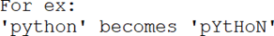

1. Write a Program that reads a string and find the sum of all the digits present in

that string. For ex: If user enters: Python@2021Then output of the program should be: 5

1. Write a Program to enter N integer elements in a Tuple and check whether all the elements are in ascending order or not.
2. Write a program to enter N Tuple pairs ((2,3),(4,5)……) ) and display total number of pairs (a,b) such that both a and b are even.
3. Write a Program to create a dictionary containing name of the students as key and their marks in 5 subjects as value separately and display information of those students whose name ends with a.
4. WAP in Python to display the following pattern.
   1. 5
   2. 4 5
   3. 3 4 5
   4. 2 3 4 5
   5. 1 2 3 4 5
5. Write a Program that inputs a line of text and print the biggest word (length wise)

from it.

1. Write a Program to enter N elements of integer type in a list and rearrange the

elements as per the following.if input list **L1** contains

|  |  |  |  |  |  |  |  |  |  |
| --- | --- | --- | --- | --- | --- | --- | --- | --- | --- |
| 2 | 5 | 7 | 9 | 4 | 8 | 3 | 1 | 10 | 6 |

|  |  |  |  |  |  |  |  |  |  |
| --- | --- | --- | --- | --- | --- | --- | --- | --- | --- |
| 2 | 5 | 7 | 9 | 4 | 8 | 3 | 1 | 10 | 6 |

Then output list L1 should contain the following

|  |  |  |  |  |  |  |  |  |  |
| --- | --- | --- | --- | --- | --- | --- | --- | --- | --- |
| 6 | 2 | 5 | 7 | 9 | 4 | 8 | 3 | 1 | 10 |

1. Suppose we have a list **L1** where each element represents the visit dates for a

particular patient in the last month. We want to calculate the highestnumbers of visits made by any patient. Write a Program to do this.A Sample list **L1** is shown below.**L1=[ [3,9], [13,20], [25], [13], [1,8,15,22,29,30], [10], [12,18,19] ]**

For the above given list L1, **the program should display the result**

**as [1,8,15,22,29,30]**

1. Wrte a Program to create a dictionary for employees containing N elements { name : salary } where N is entered by user and delete the element from the dictionary whose name starts with 'A' and ends with 'a', also count number of employees deleted.
2. A dictionary D1 has values in the form of list of integers. Write a Program to
   1. create a new dictionary D2 having same keys as D1 but values as the average of
   2. the list elements.

c.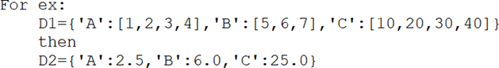

1. Write a Program to enter information N students as a Tuple (rn, name and (marks in 5 subjects as a Tuple)) and display the grade of each student with name. Percentage : Grade

**Functions :**

1. Write a user defined function to add 2 numbers and display their sum.
2. Write a program using a user defined function that displays sum of first n natural numbers, where n is passed as an argument.
3. Write a program using user defined function that accepts an integer and increments the value by 5. Also display the id of argument (before function call), id of parameter before increment and after increment.
4. Write a program using a user defined function myMean() to calculate the mean of

floating values passed as an argument. Use variable length arguments.

1. Write a program using a user defined function calcFact() to calculate and display

the factorial of a number num passed as an argument.

1. Write a program using a user defined function that accepts the first cname and lastname as arguments, concatenate them to get full name and displays the output as: Hello full name
2. Write a program that simulates a traffic light . The program should consist of the

following: 1. A user defined function trafficLight( ) that accepts input from the user, displays an error message if the user enters anything other than RED, YELLOW, and GREEN. Function light() is called and the following is displayed depending upon return value from light(). a) “STOP, your life is precious” if the value returned by light() is 0.

b) “Please WAIT, till the light is Green “ if the value returned by light() is 1 c) “GO! Thank you for being patient” if the value returned by light() is 2.

2. A user defined function light() that accepts a string as input and returns 0 when the input is RED, 1 when the input is YELLOW and 2 when the input is GREEN. The input should be passed as an argument.

3. Display “ SPEED THRILLS BUT KILLS”

1. Create a user defined module basic_ math that contains the following user defined functions:
   1. To add two numbers and return their sum.
   2. To subtract two numbers and return their difference.
   3. To multiply two numbers and return their product.
   4. To divide two numbers and return their quotient and print “Division by Zero” error if the denominator is zero. Create a menu driven program using user defined functions to implement a calculator that performs the following:a) Basic arithmetic operations(+,-,*,/) b) log10(x),sin(x),cos(x)
2. To secure your account, whether it be an email, online bank account or any other account, it is important that we use authentication. Use your programming expertise to create a program using user defined function named login that accepts userid and password as parameters (login(uid,pwd)) that displays a message “account blocked” in case of three wrong attempts. The login is successful if the user enters user ID as "ADMIN" and password as "St0rE@1". On successful login, display a message “login successful”.
3. ABC School has allotted unique token IDs from (1 to 600) to all the parents for facilitating a lucky draw on the day of their Annual day function. The winner would receive a special prize. Write a program using Python that helps to automate the task.(Hint: use random module
4. Write a program that has a user defined function to accept the coefficients of a quadratic equation in variables and calculates its determinant. For example : if the coefficients are stored in the variables a,b,c then calculate determinant as b2-4ac. Write the appropriate condition to check determinants on positive, zero and negative and output appropriate result.
5. Write a program that creates a GK quiz consisting of any five questions of your choice. The questions should be displayed randomly. Create a user defined function score() to calculate the score of the quiz and another user defined function remark (scorevalue) that accepts the final score to display remarks as follows:

Marks Remarks

5 Outstanding

4 Excellent

3 Good

2 Read more to score more

1 Needs to take interest

0 General knowledge will always help you. Take it seriously.

1. Write a program to find the number n is prime or not using recursive function checkprime()
2. Write the program to search a number in the list of sorted numbers using a method of recursive binary search algorithm.

**File Handling**

1. Write a method in Python to read lines from a text file DIARY.TXT, and display those lines, which are starting with an alphabet ‘s’.
2. Reena has used a text editing software to type some text. After saving the article as WORDS.TXT, she realised that she has wrongly typed alphabet J in place of alphabet I everywhere in the article. Write a function definition for JTOI()in python that would display the corrected version of entire content of the file WORDS.TXT with all the alphabets “J” to be displayed as an alphabet “I” on screen.

Note : Assuming that WORD.TXT does not contain any J alphabet otherwise.

Example : If Reena has stored the following content in the file WORDS.TXT :WELL, THJS JS A WORD BY JTSELF. YOU COULD STRETCH THJS TO BE A SENTENCE

The function JTOI( ) should display the following content :WELL, THIS IS A WORD BY ITSELF. YOU COULD STRETCH THIS TO BE A SENTENCE

1. Write a function definition ARTICLES() in python to count all the articles “the”, “a” and “an” present in a text file “BOOK.TXT”.Note : Ensure that “the”, “a” and “an” are counted as independent words and not as a part of any other word.Example : If the following is content in the file BOOK.TXT :We should choose a low fat diet. The chef is really good in the hotel. An article came in the newspaper about him.The function ARTICLE( ) should display the following output : 5
2. Write a function definition remove () in python to remove all the articles “the”, “a” and “an” and short words like “is”, “on”,”in”,”of” present in a text file “BOOK.TXT”.Example : If the following is content in the file BOOK.TXT :We should choose a low fat diet. The chef is really good in the hotel. An article came in the newspaper about him.The function remove() should display the following output : We should choose low fat diet.chef really good hotel.article came newspaper about him.
3. Write a program to enter the following records in a binary file:

Item No integerItem_Name stringQty integerPrice float

Number of records to be entered should be accepted from the user. Read the file to display the records in the following format:

Item No: Item Name :

Quantity:Price per item:Amount:

1. Consider a binary file Stock.dat that has the following data:

OrderId, MedicineName, Quantity Price of all the Medicines of Wellness Medicos.

Write the following functions:

(i) AddOrder() that can input all the medicine orders.

(ii) DisplayPrice() to display the price of all the medicines that have price > 500.

(iii) Modifyorder() to modify the order details

(iv) Deleteorder() to delete order details

1. Following is the structure of each record in a data file named “PRODUCT.DAT”.  {"prod_code": value, "prod_desc": value, "stock": value}

The values for prod_code and prod_desc are strings and the value for stock is an integer. Write a function in Python to update the file with a new value of stock. The stock and the product_code, whose stock is to be updated, are to be inputted during the execution of the function

PRACTICAL 1

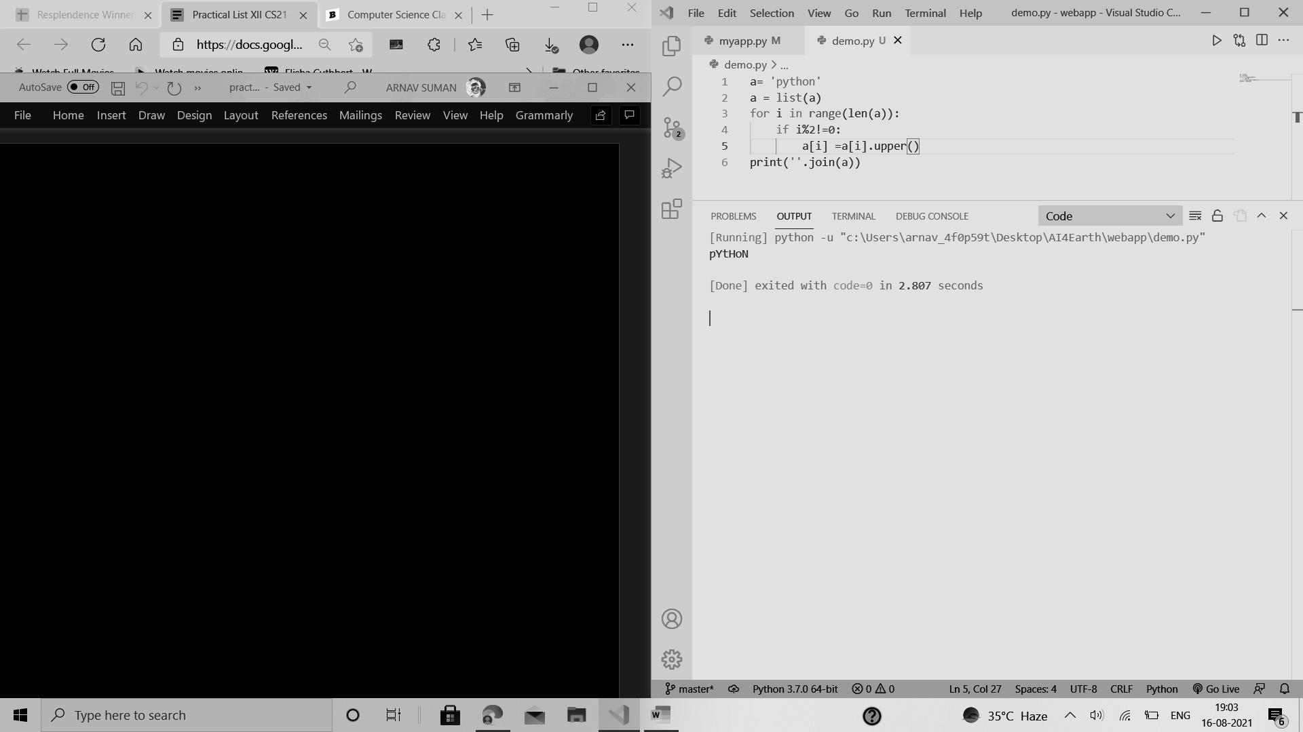

PRACTICAL 2

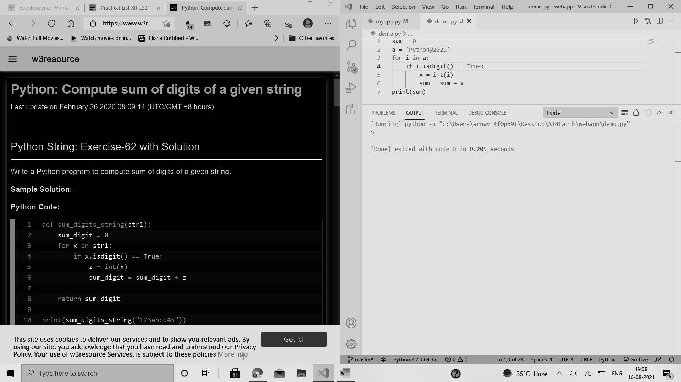

PRACTICAL 3

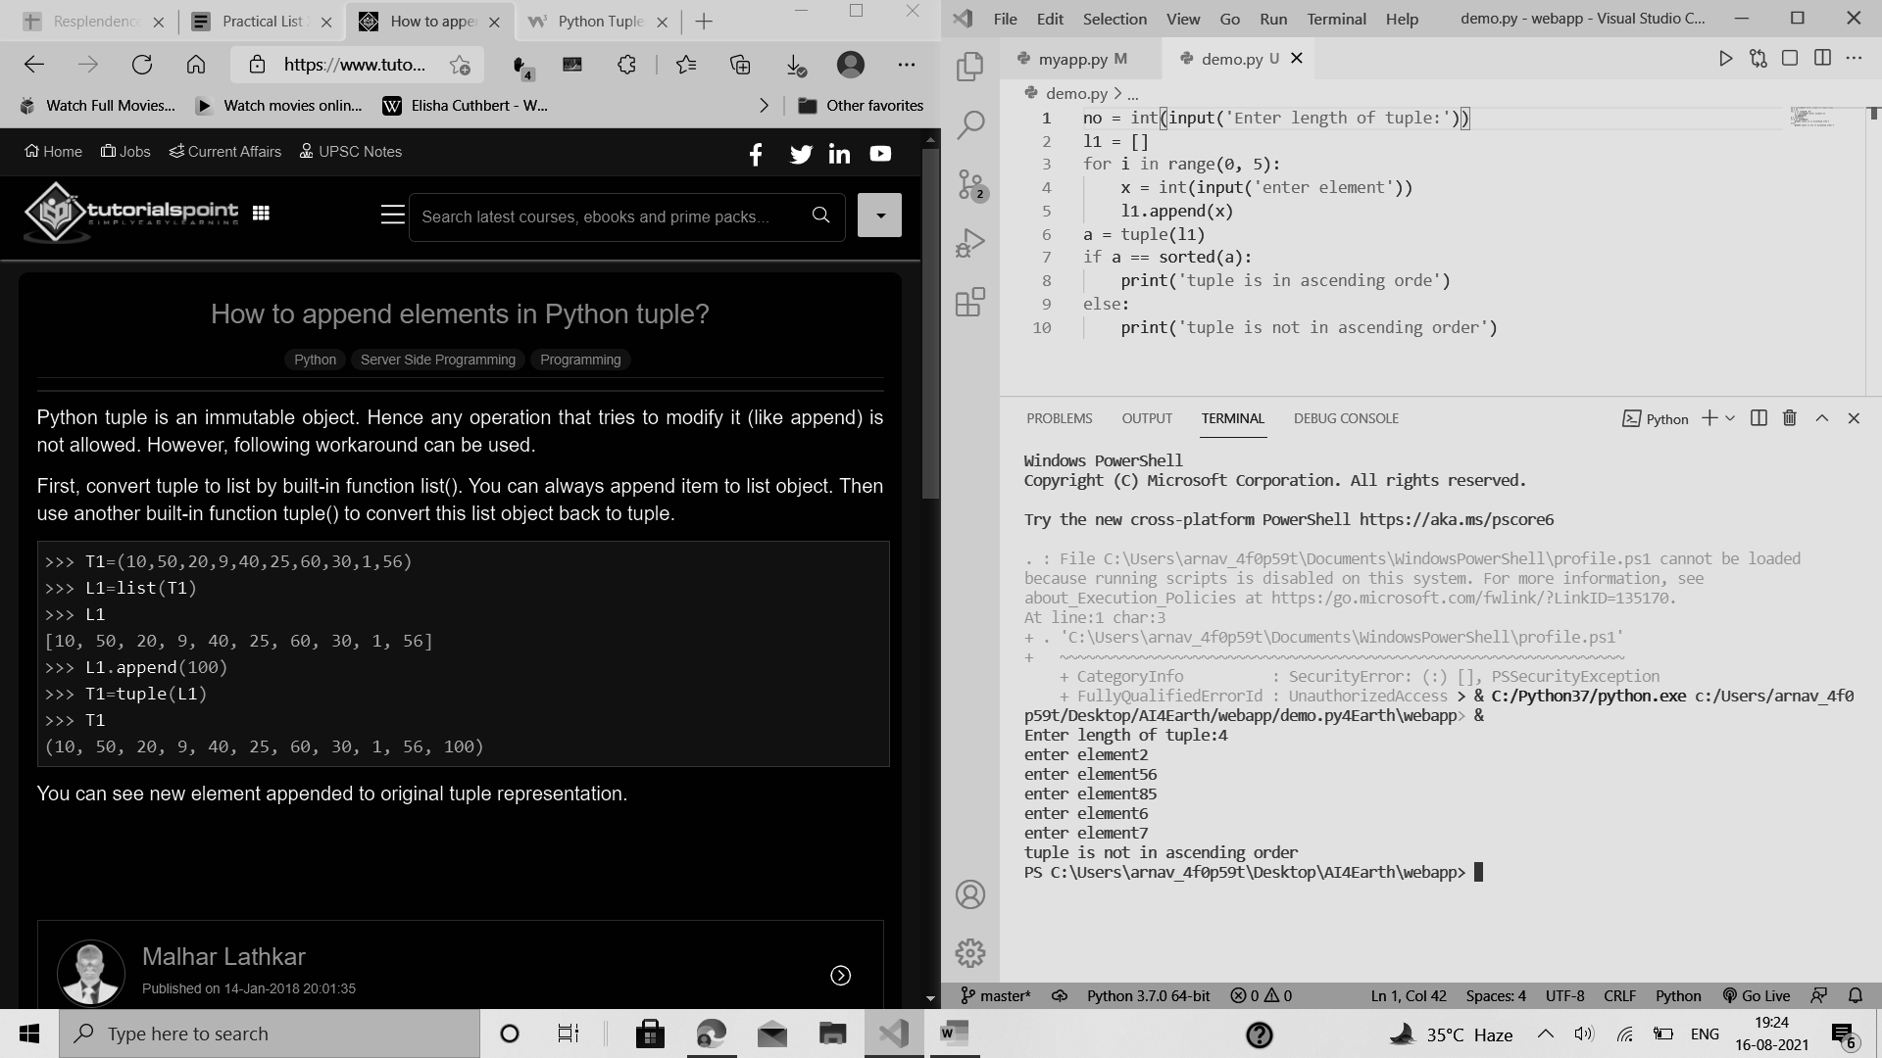

PRACTICAL 4

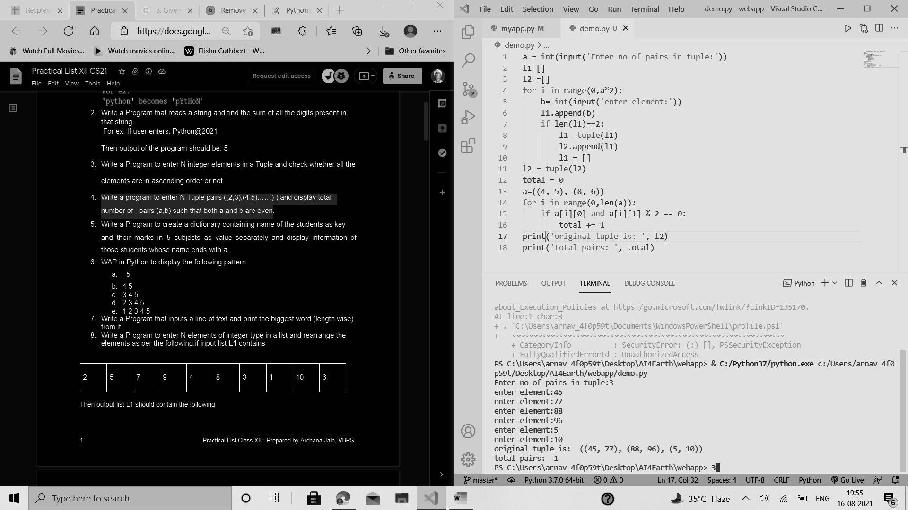

PRACTICAL 5

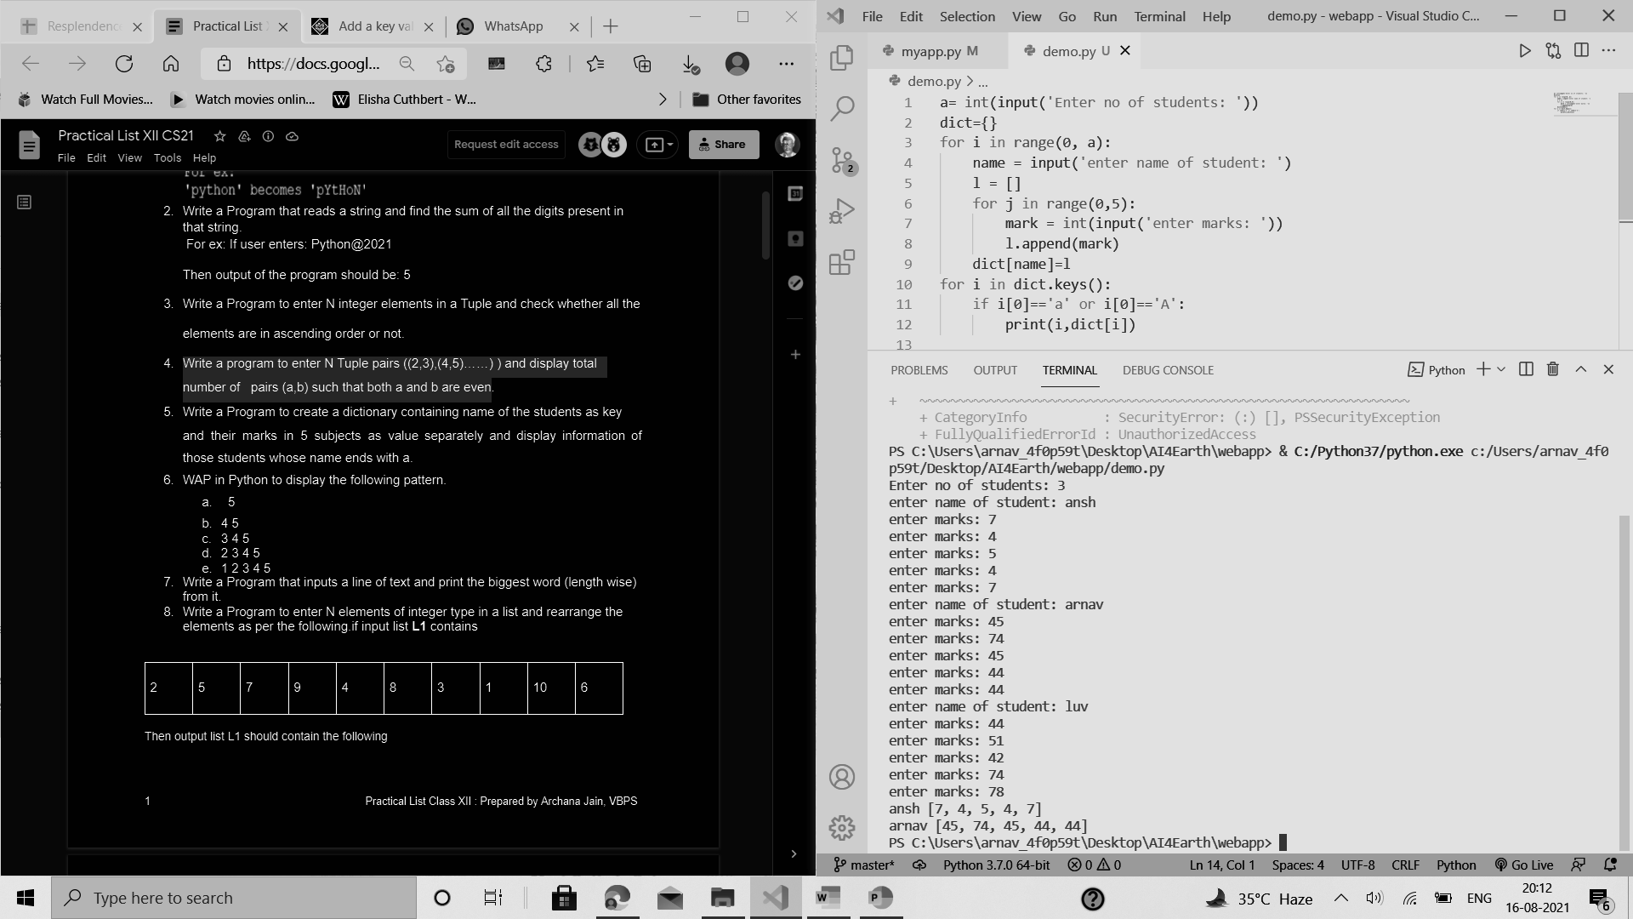

PRACTICAL 6

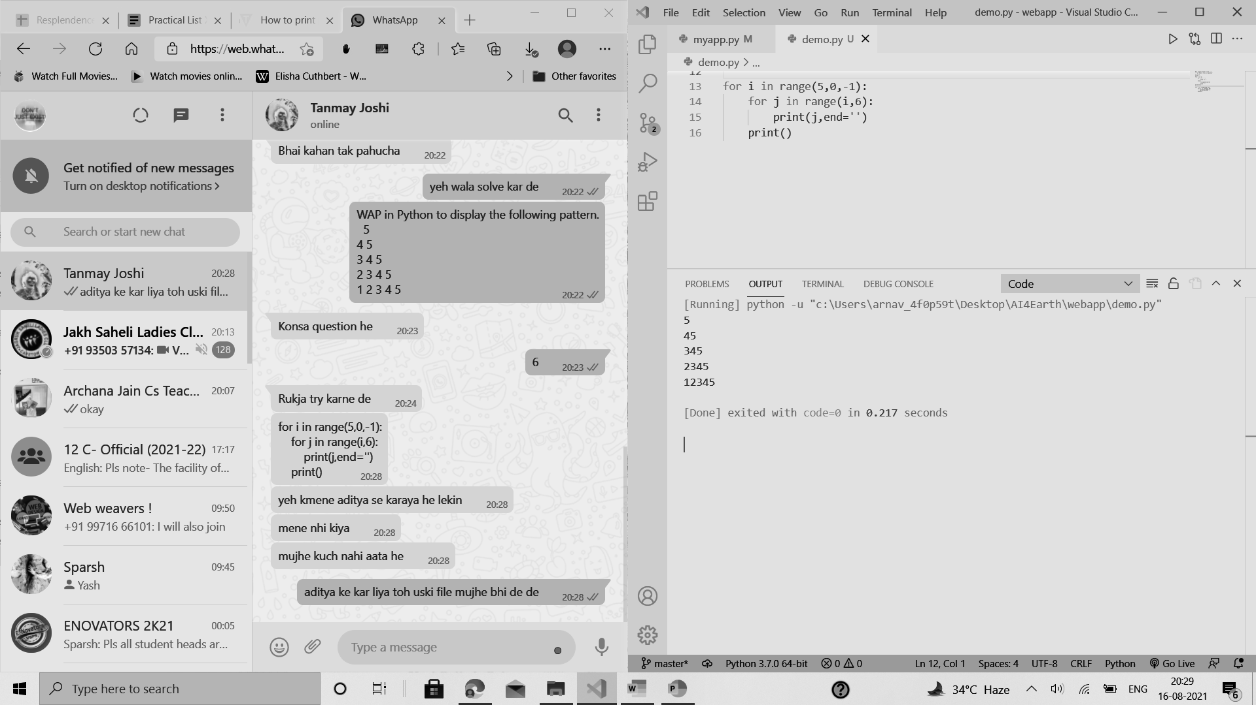

PRACTICAL 7

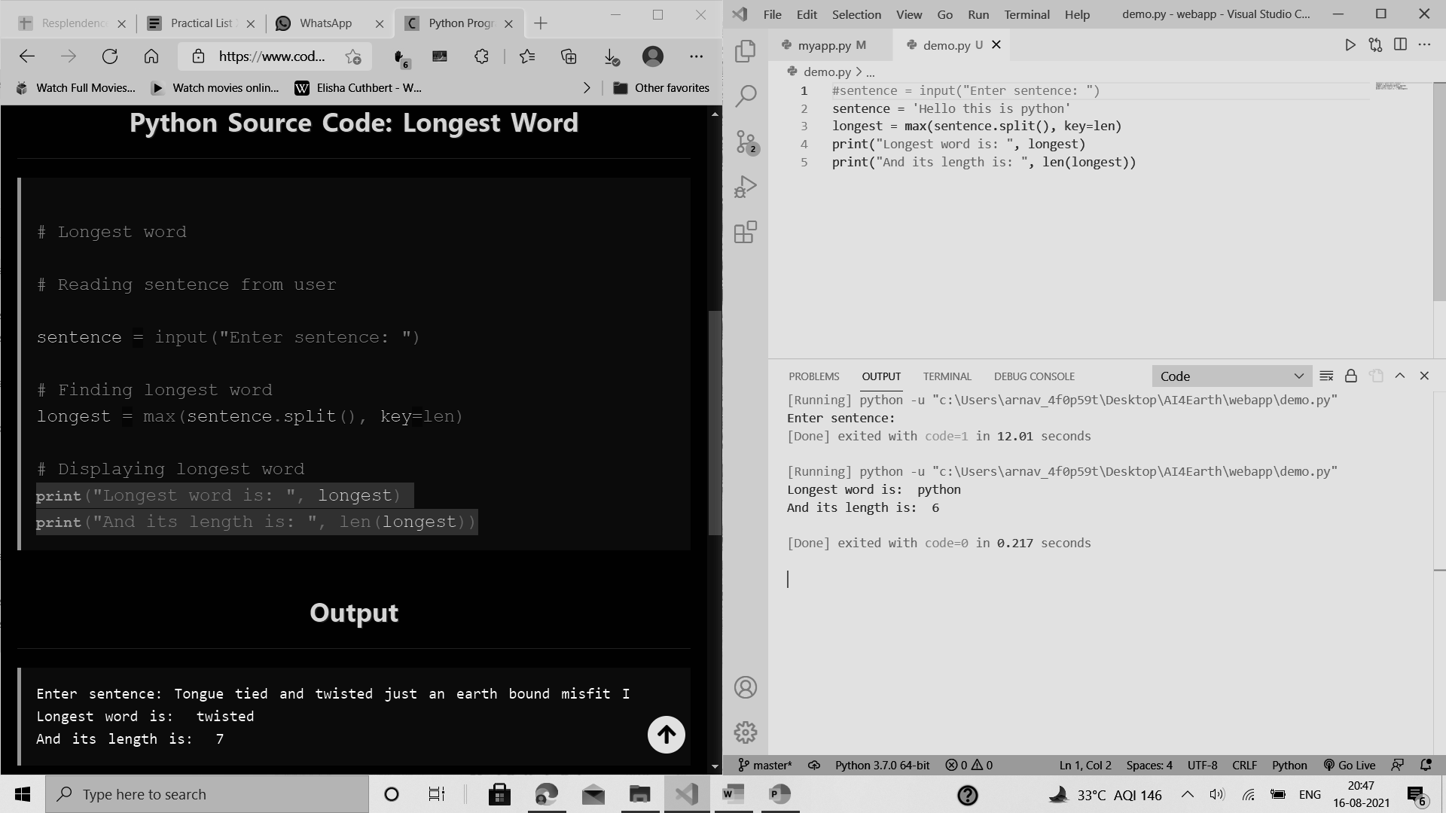



PRACTICAL 8

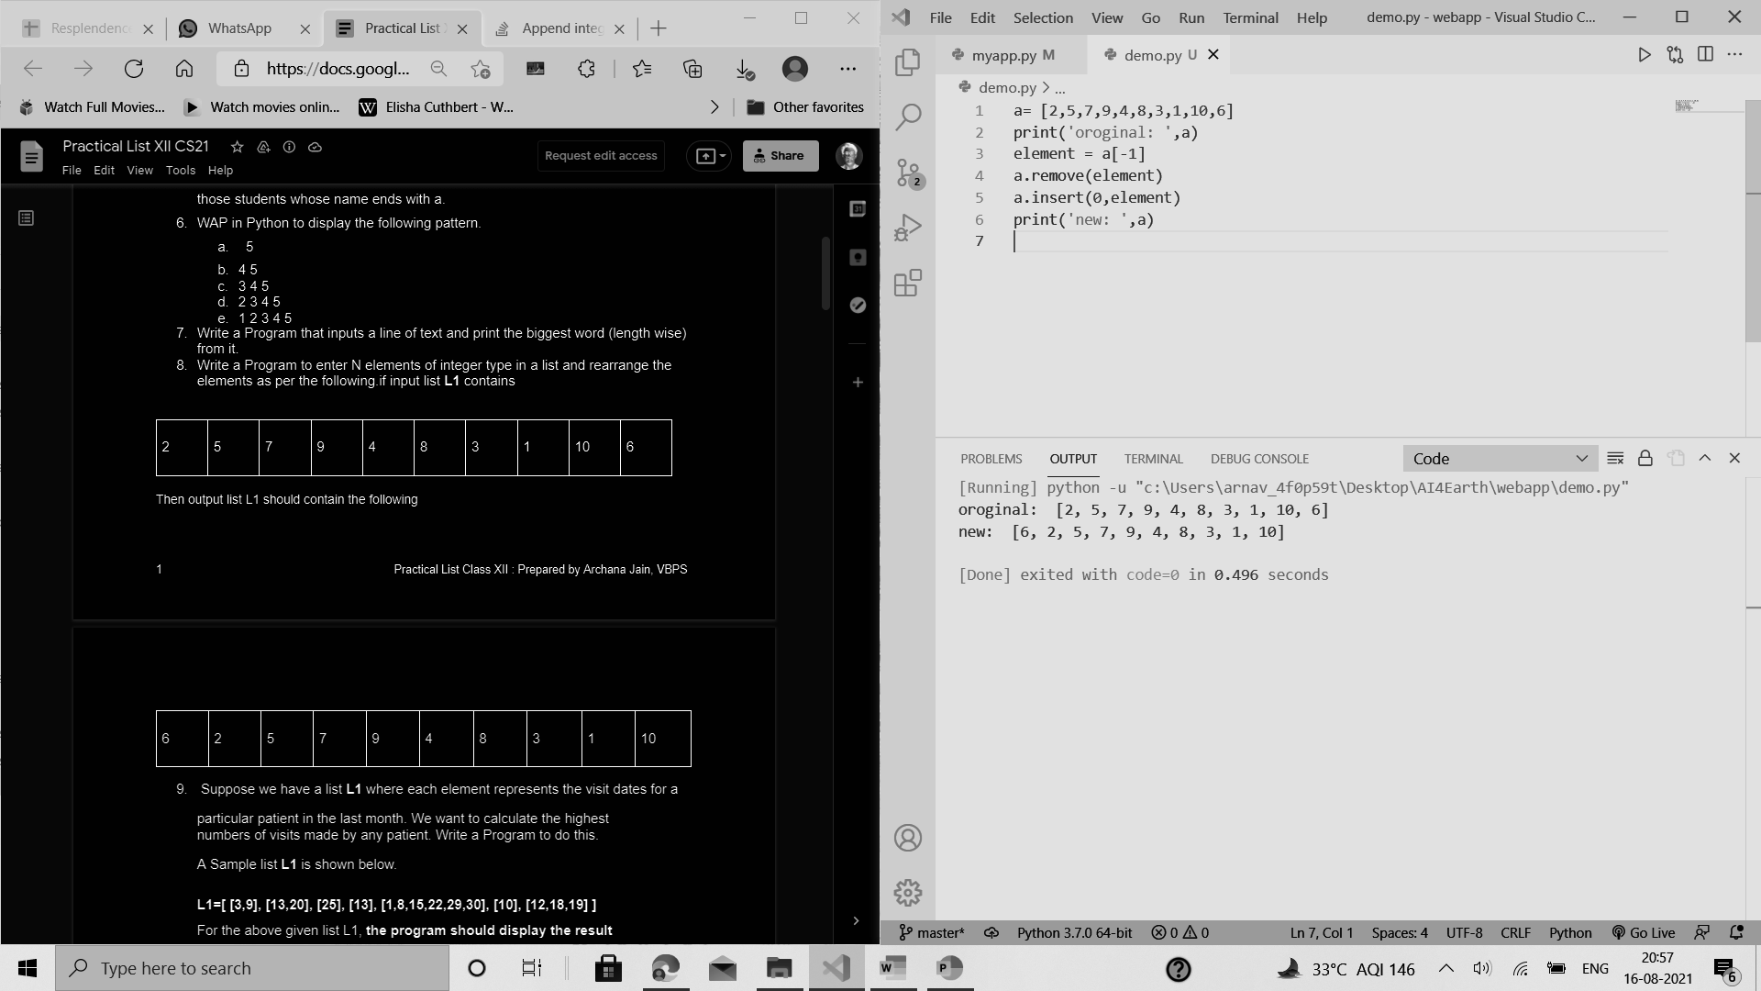

PRACTICAL 9

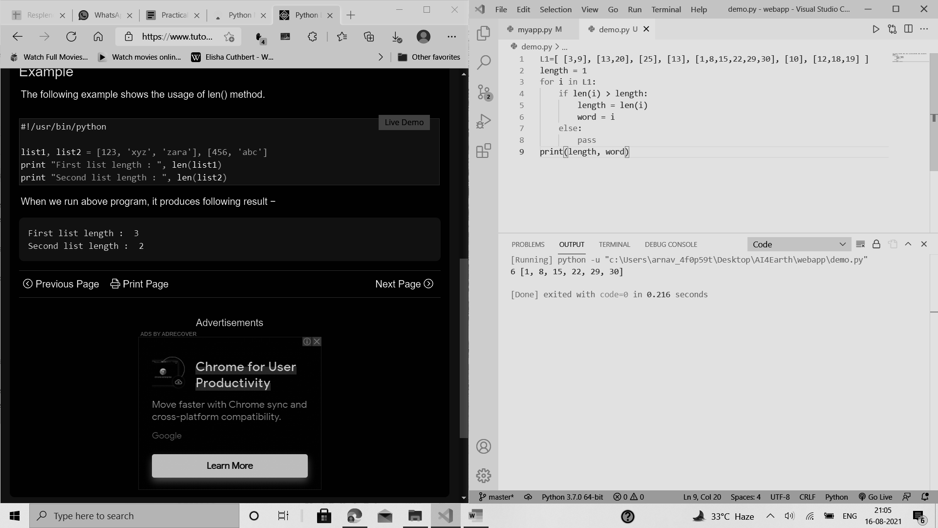

PRACTICAL 10

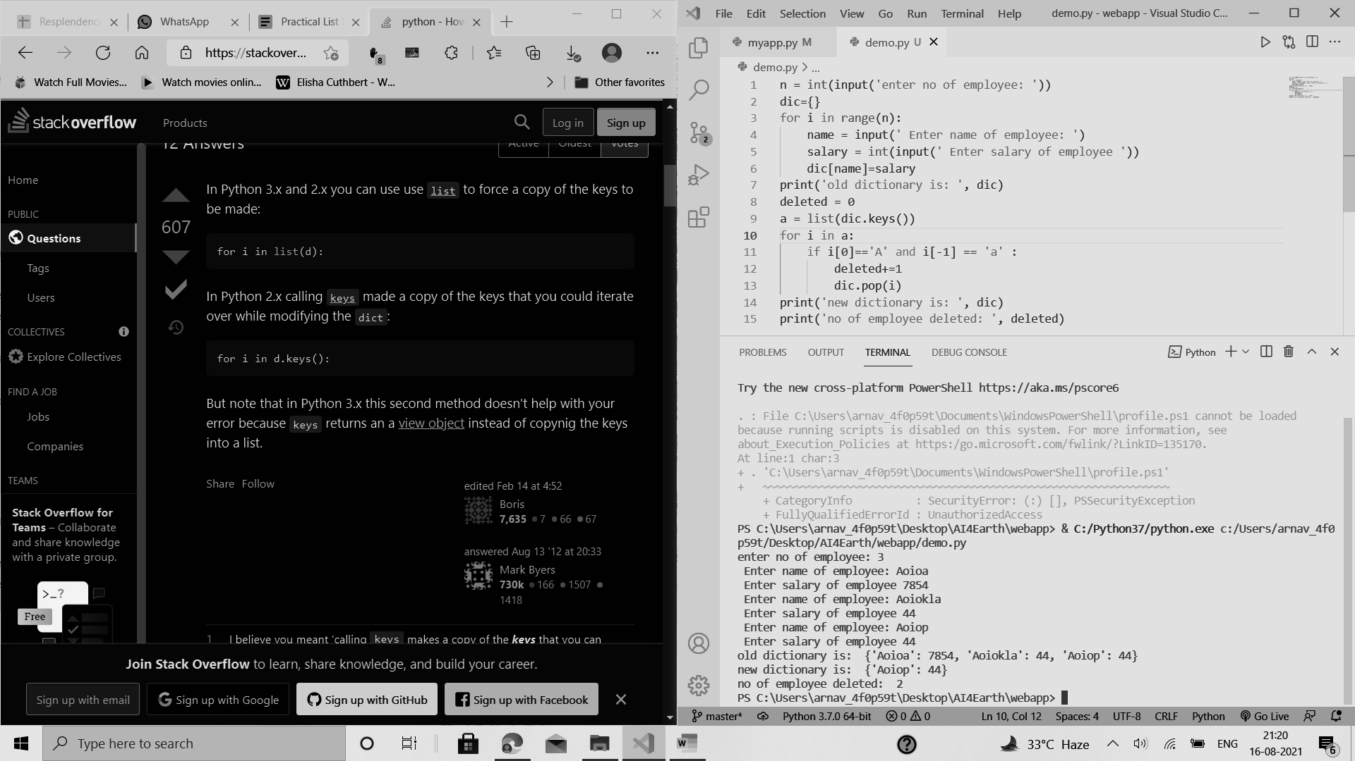

PRACTICAL 11

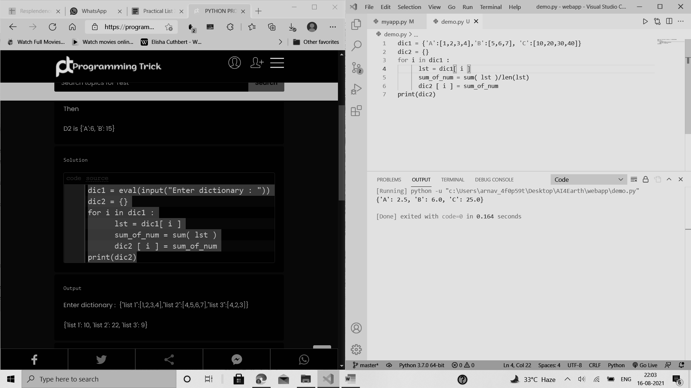

PRACTICAL 12 PROMPT

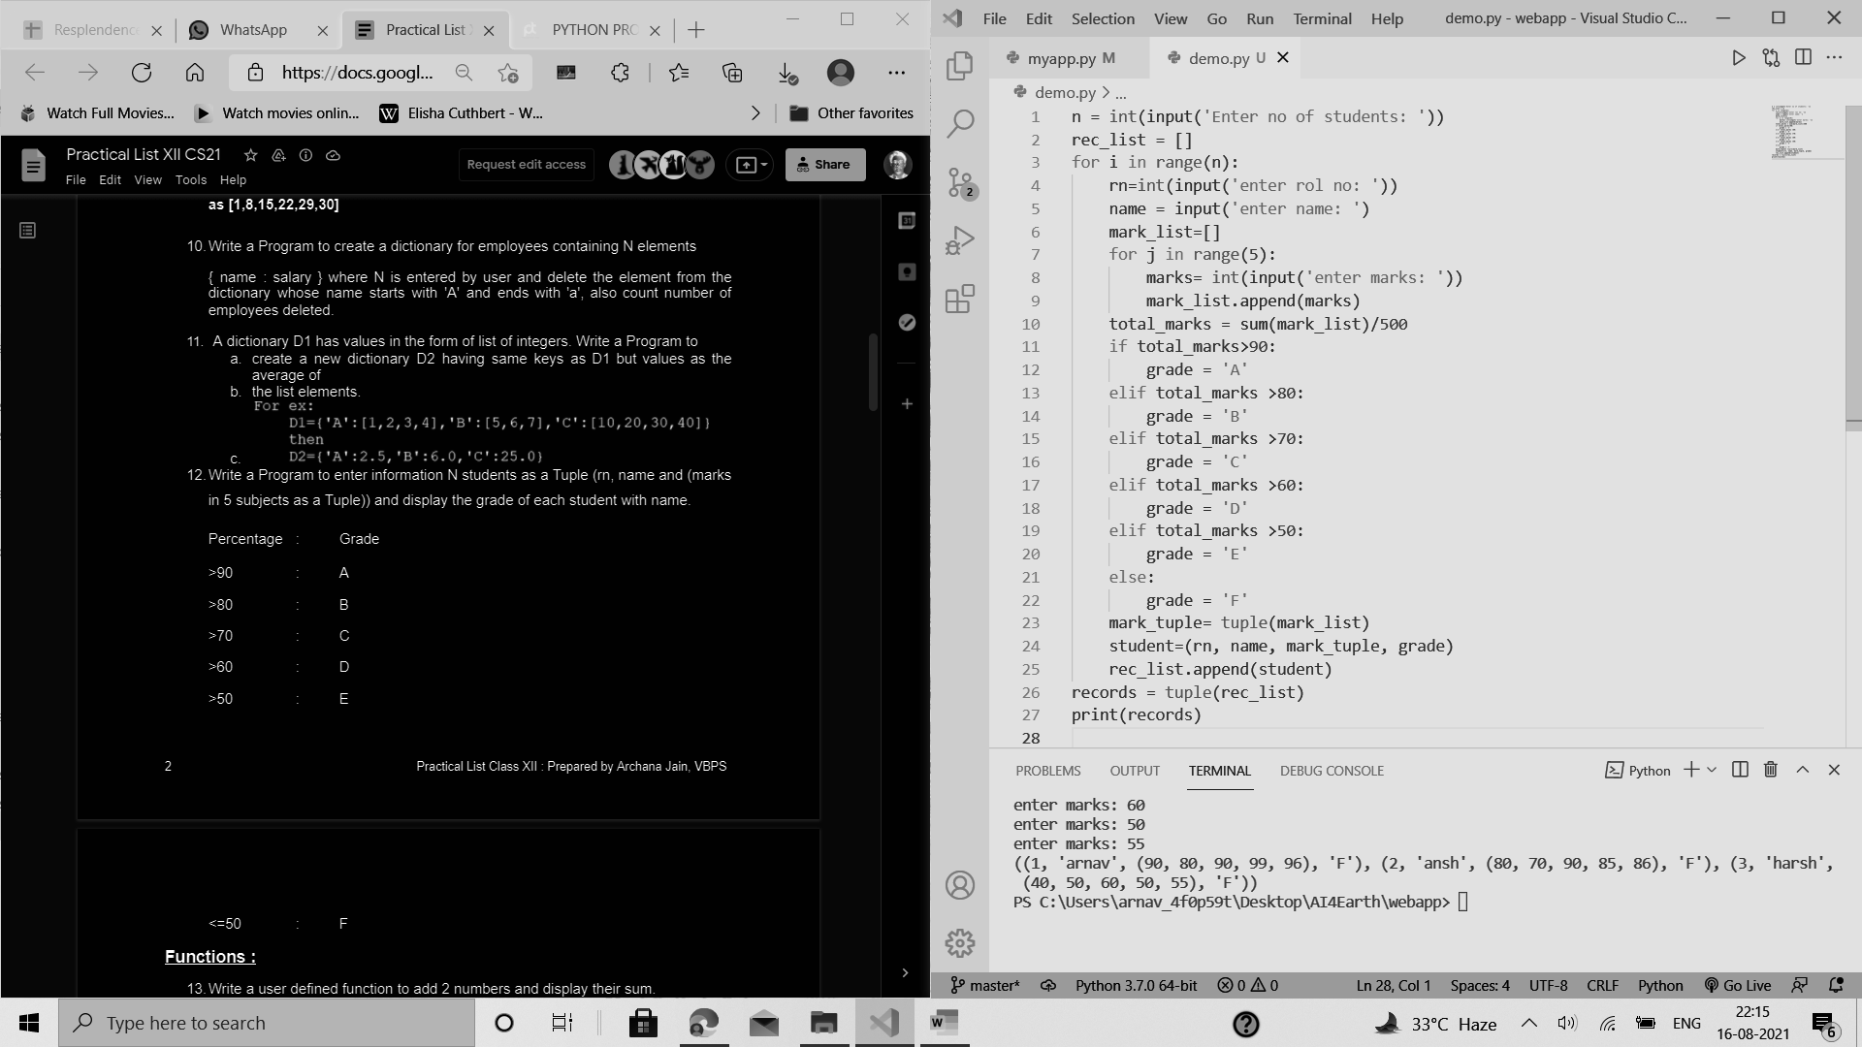

PRACTICAL 12 OUTPUT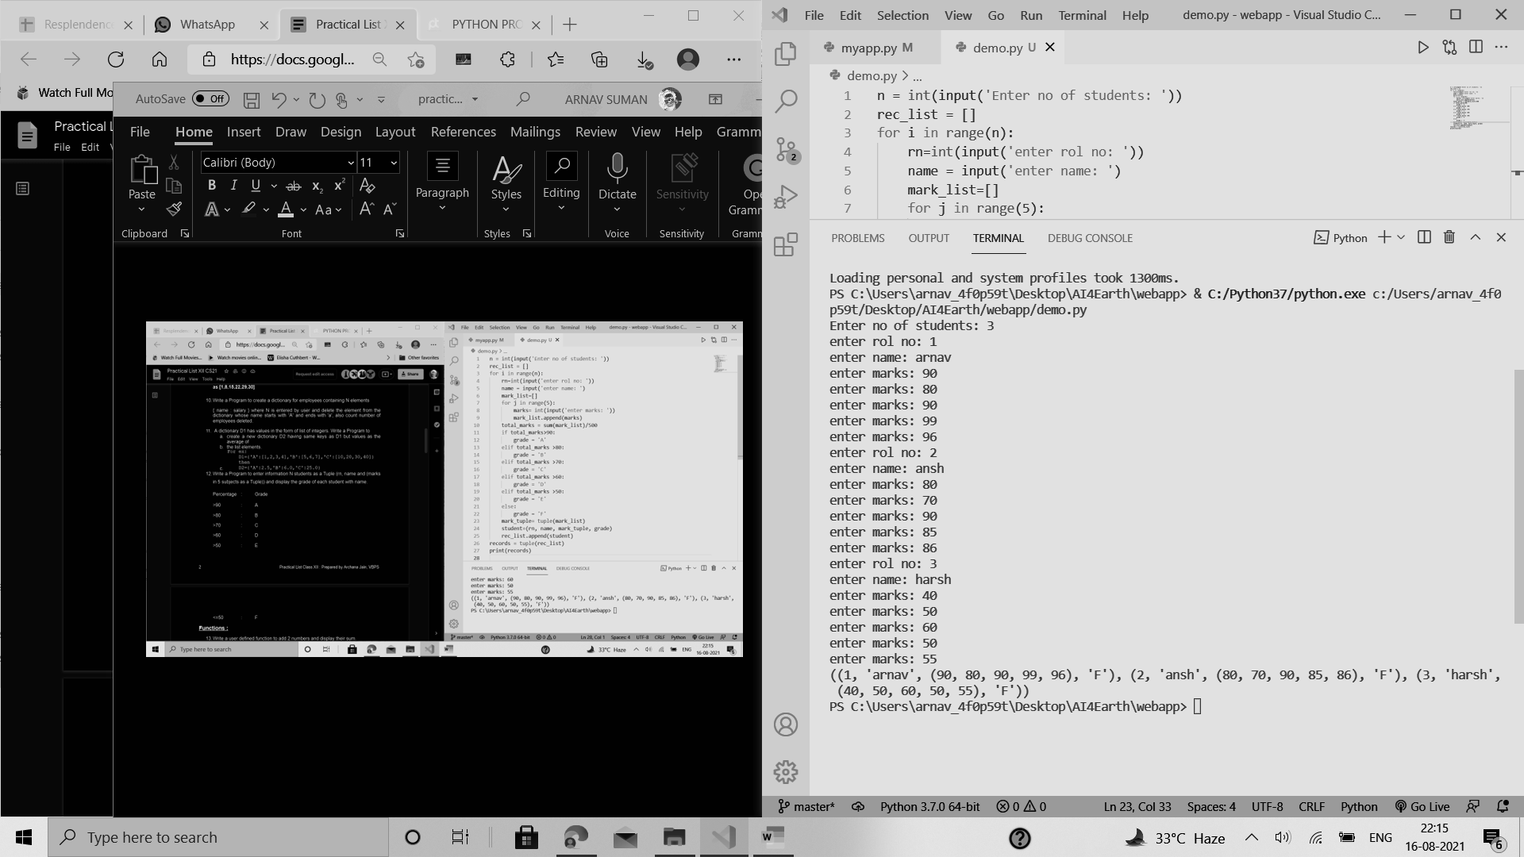

FUNCTIONS PRACTICAL 13

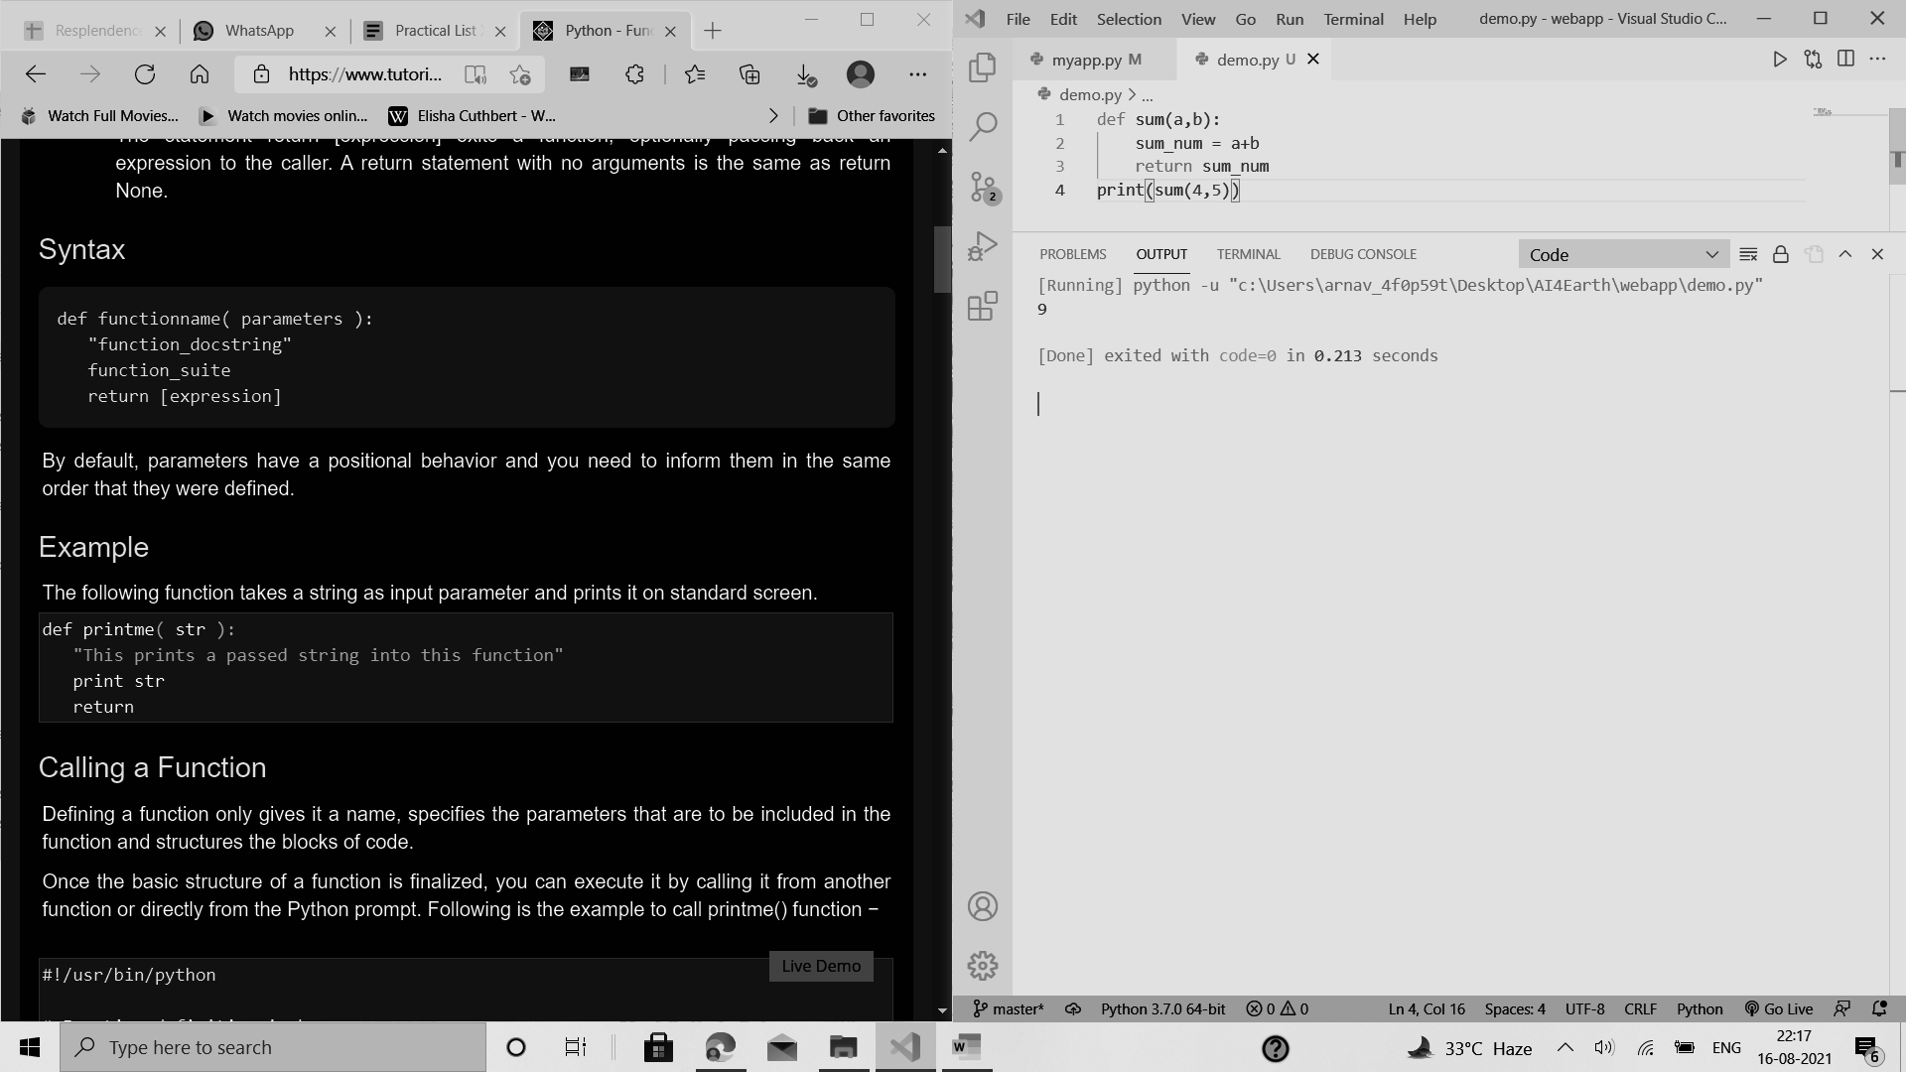

PRACTICAL 14

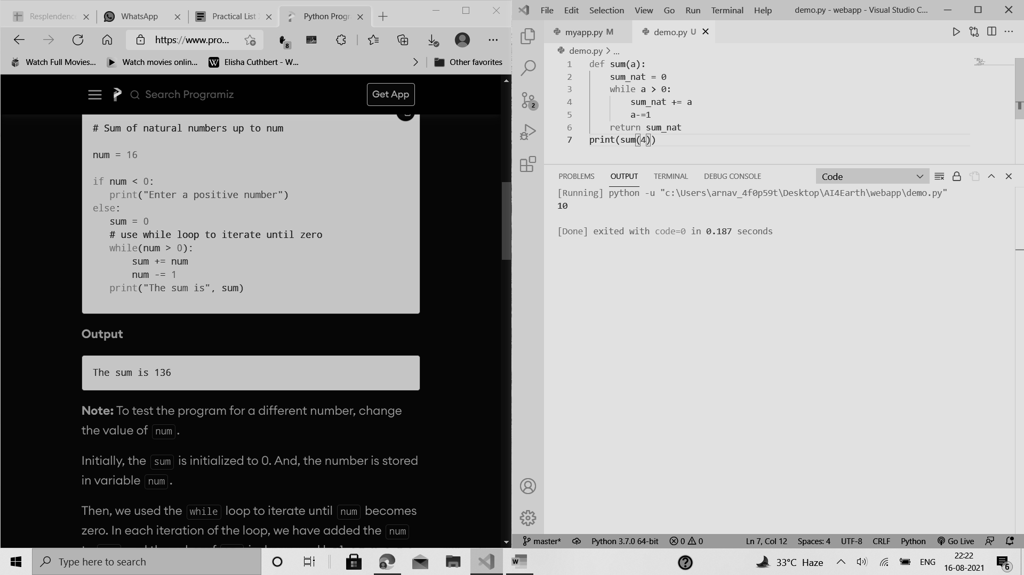

PRACTICAL 15

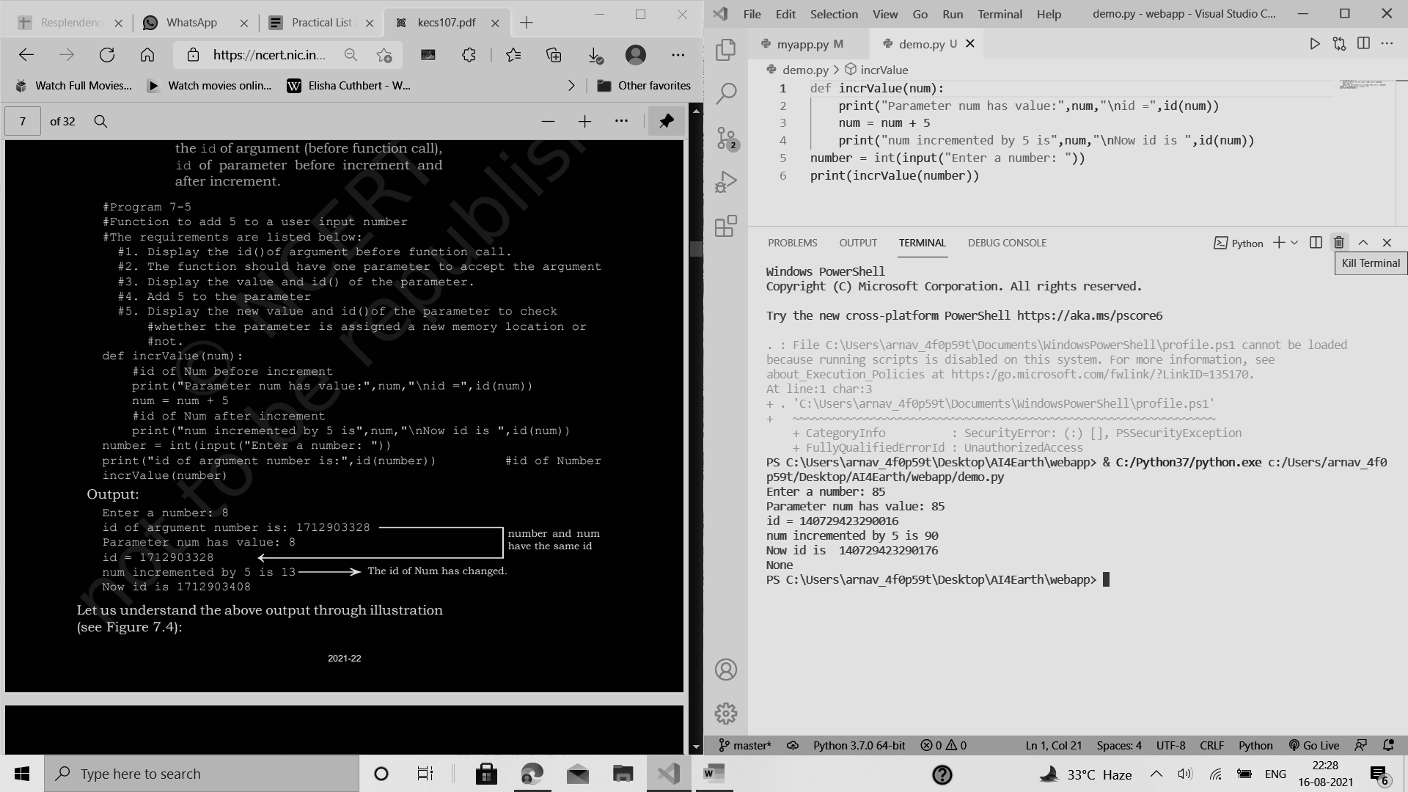

PRACTICAL 16

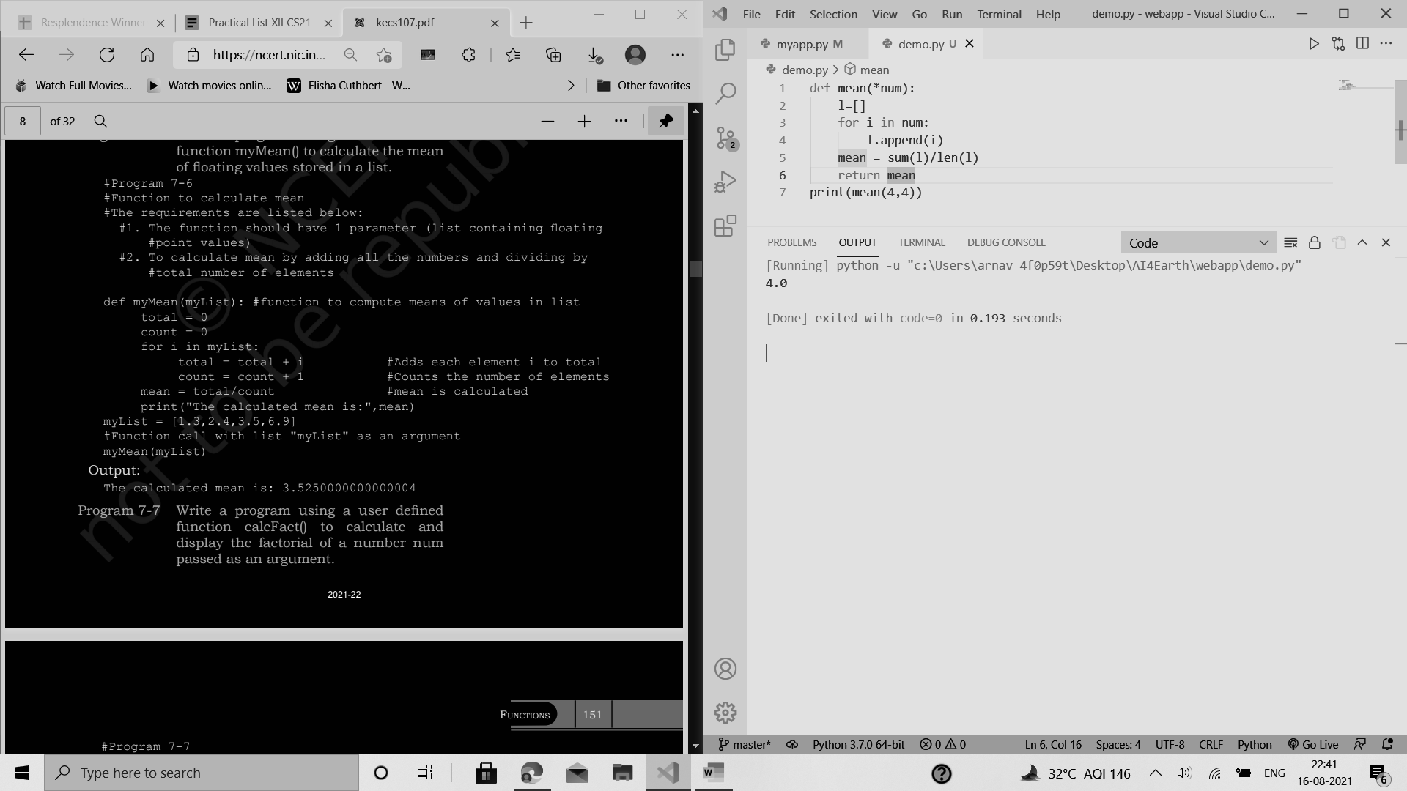

PRACTICAL 17

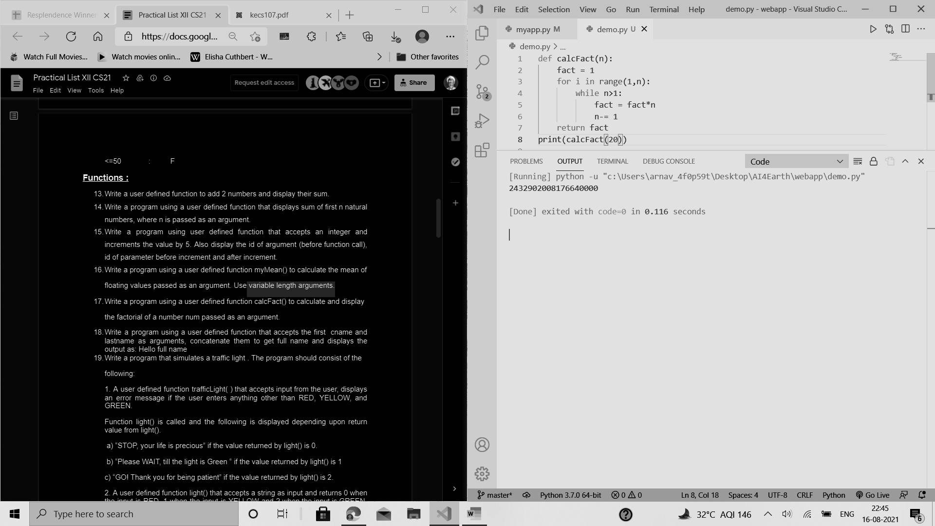

PRACTICAL 18

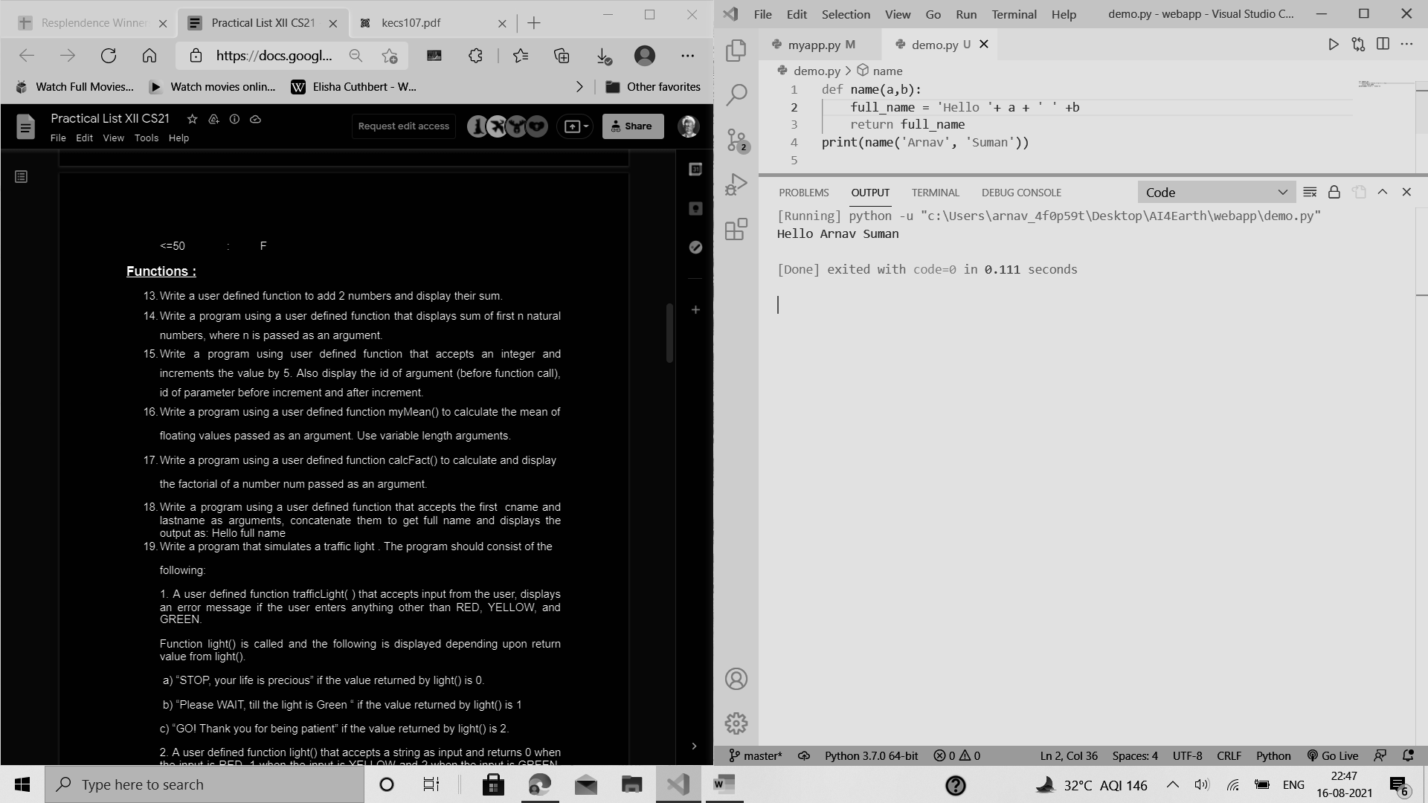

PRACTICAL 19

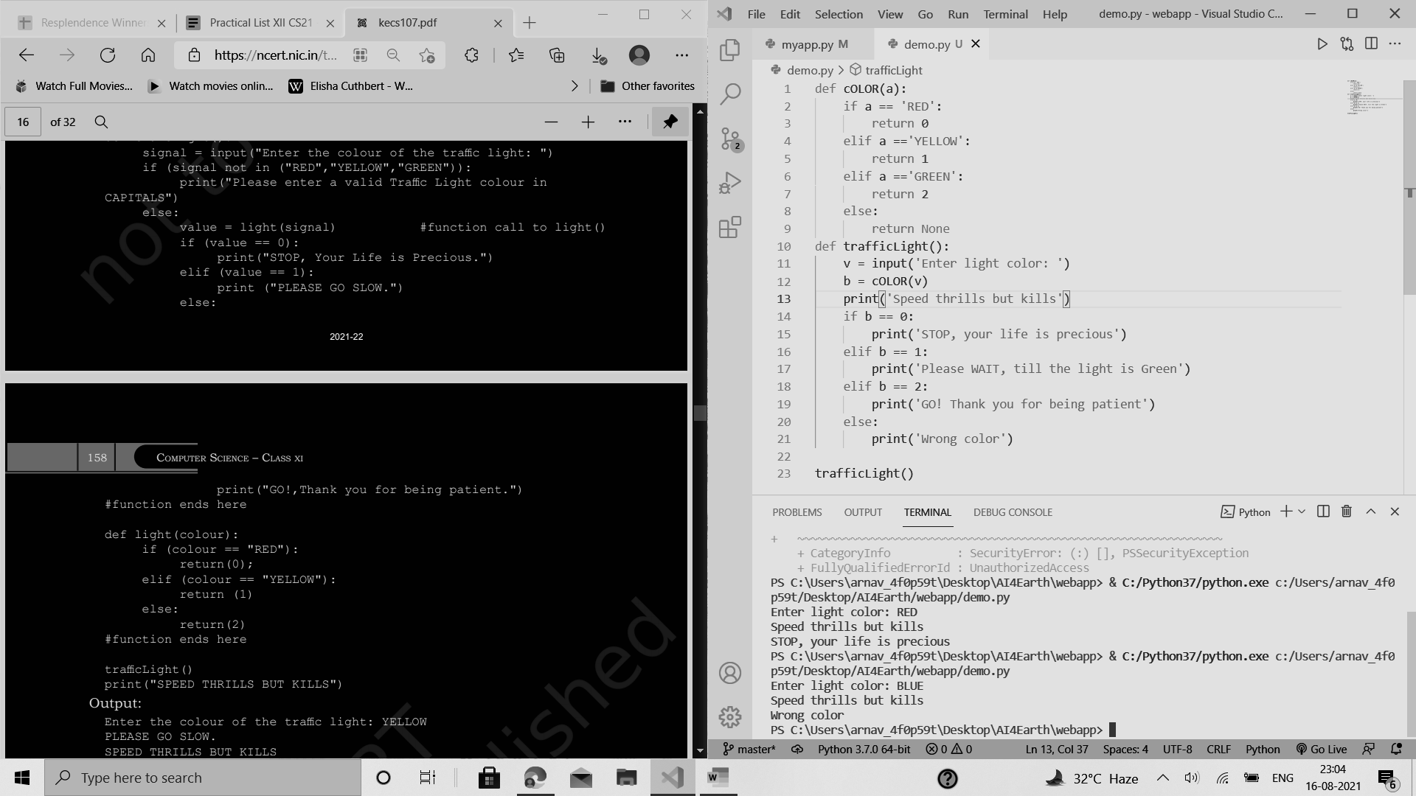

PRACTICAL 20

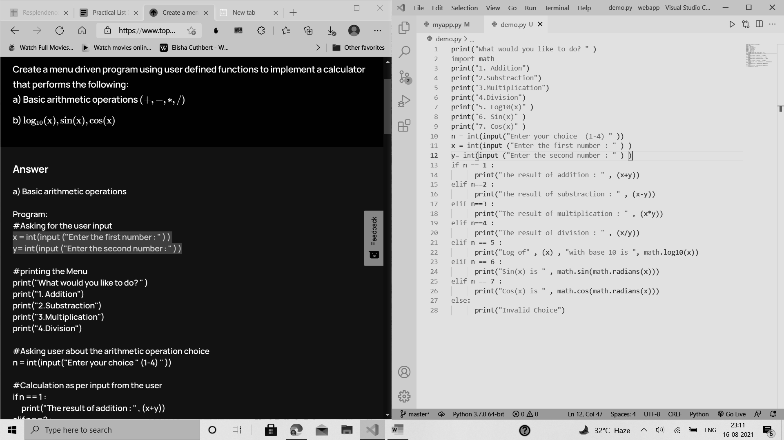

PRACTICAL 21

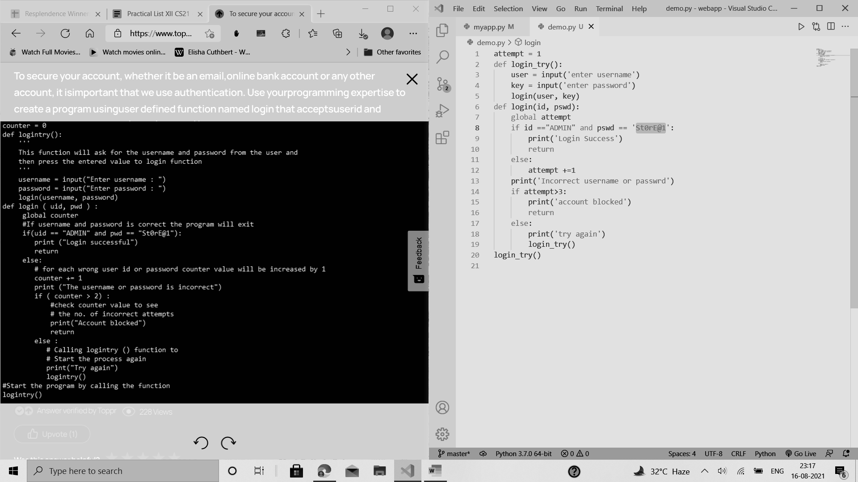

PRACTICAL 22

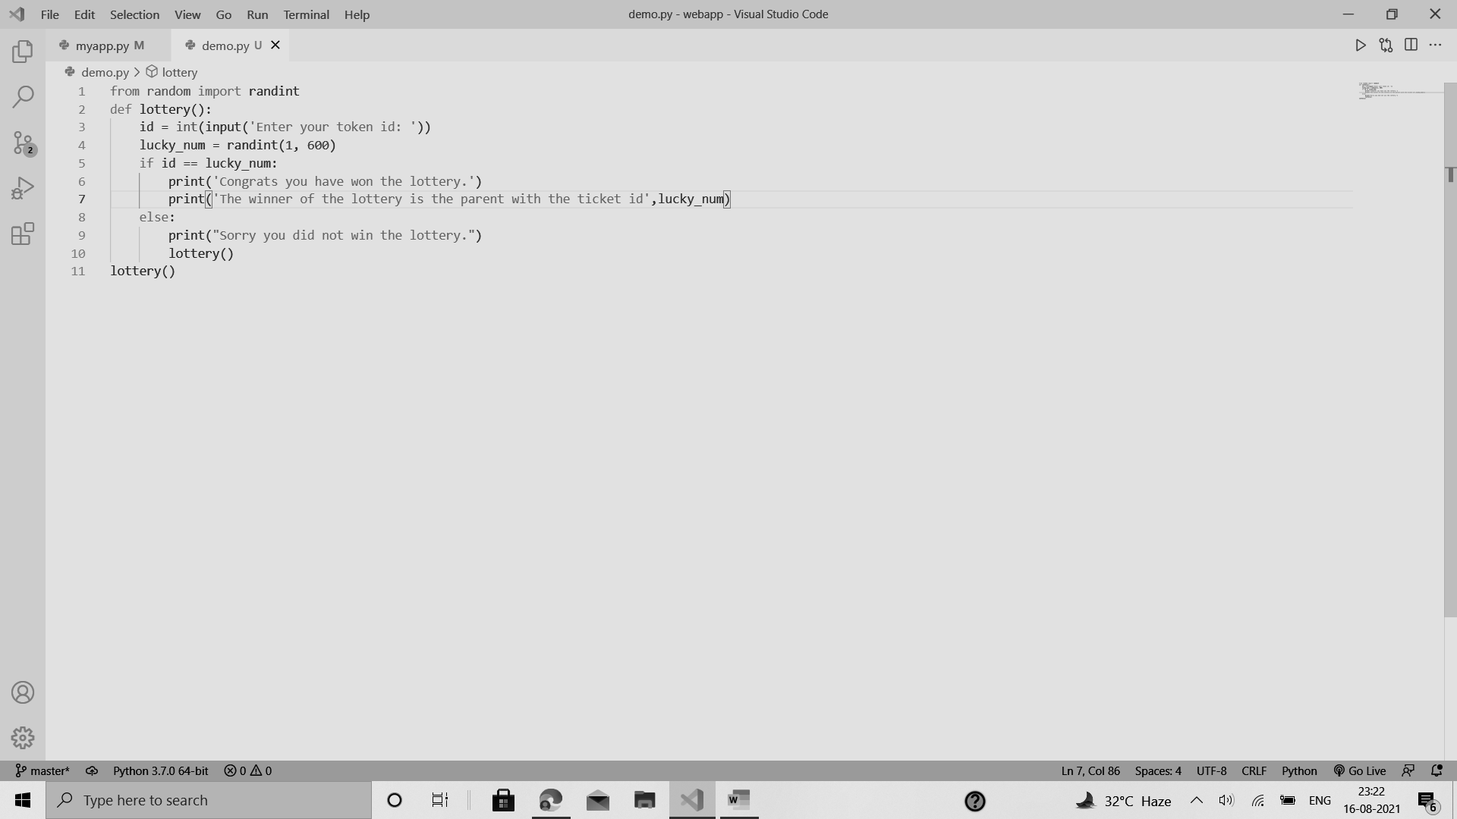

PRACTICAL 23

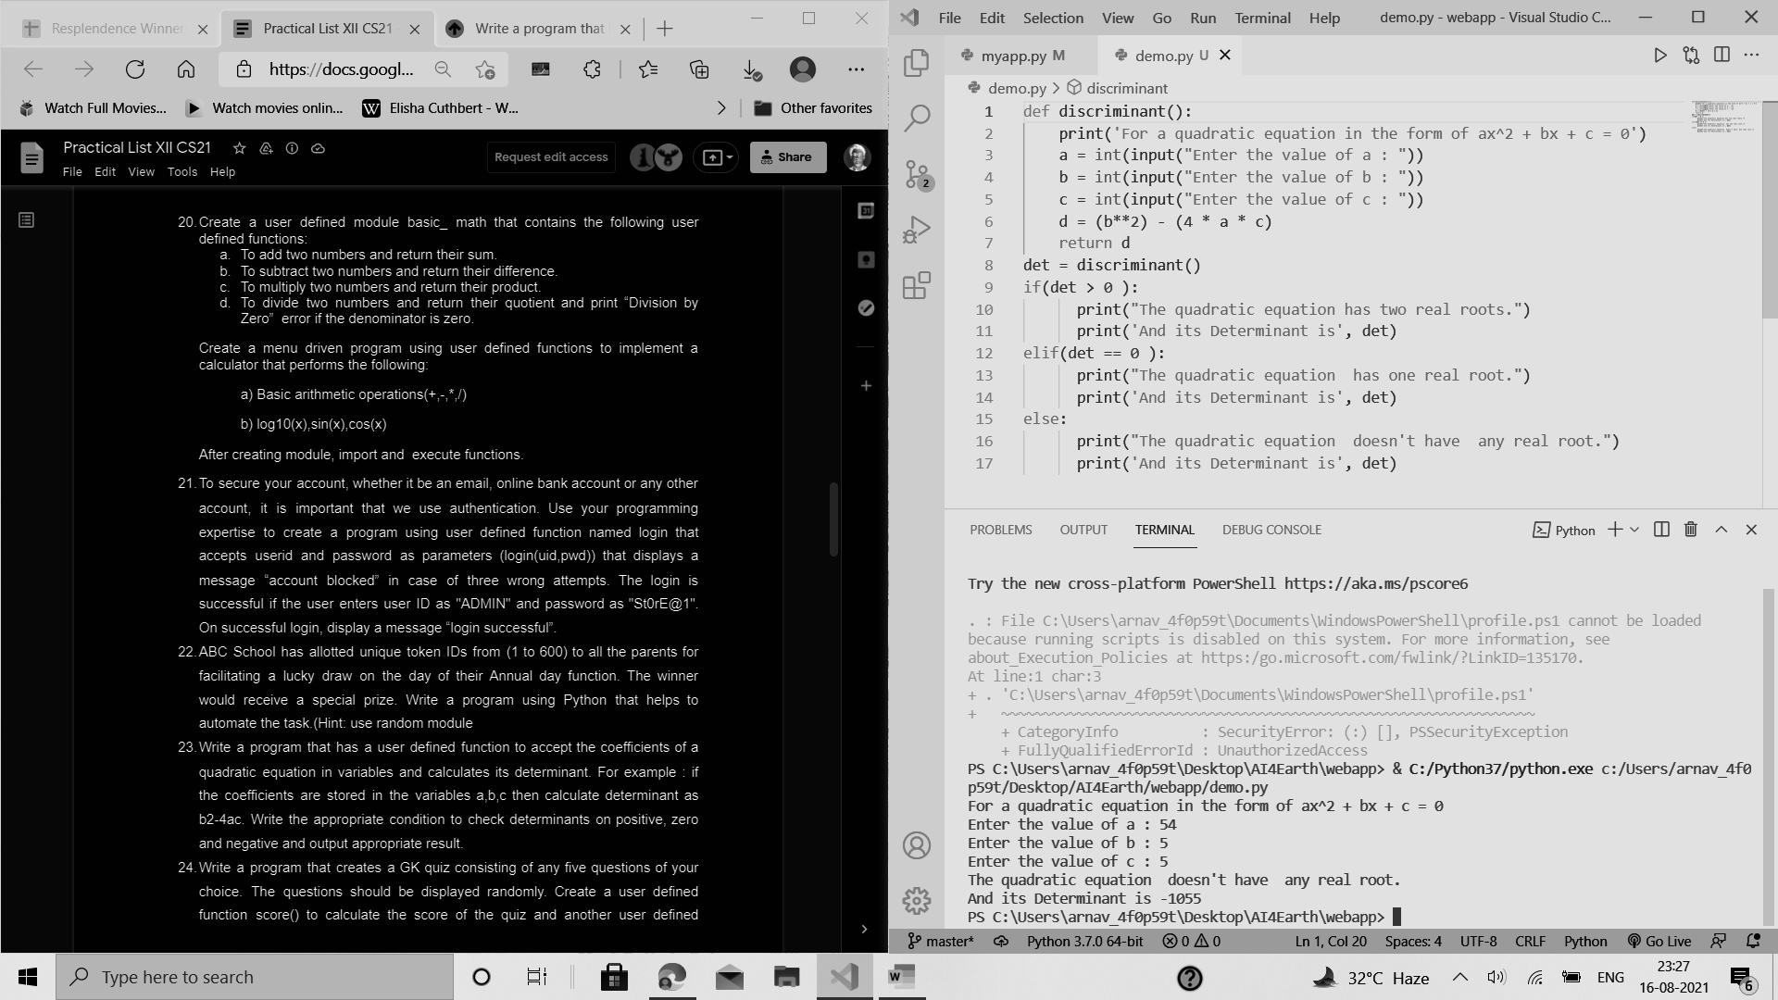

PRACTICAL 24

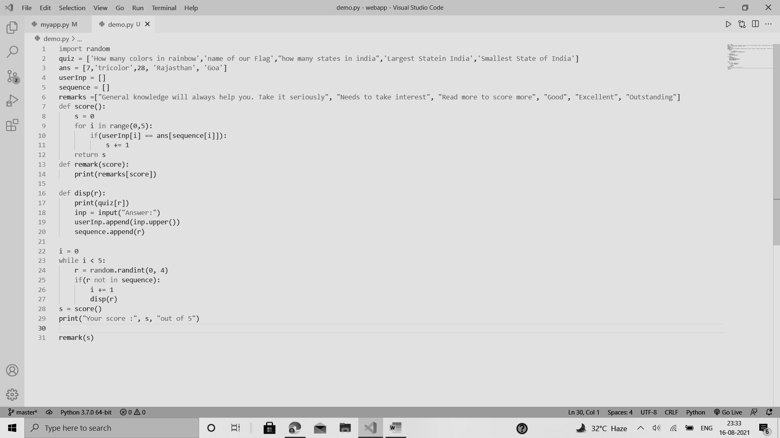

PRACTICAL 25

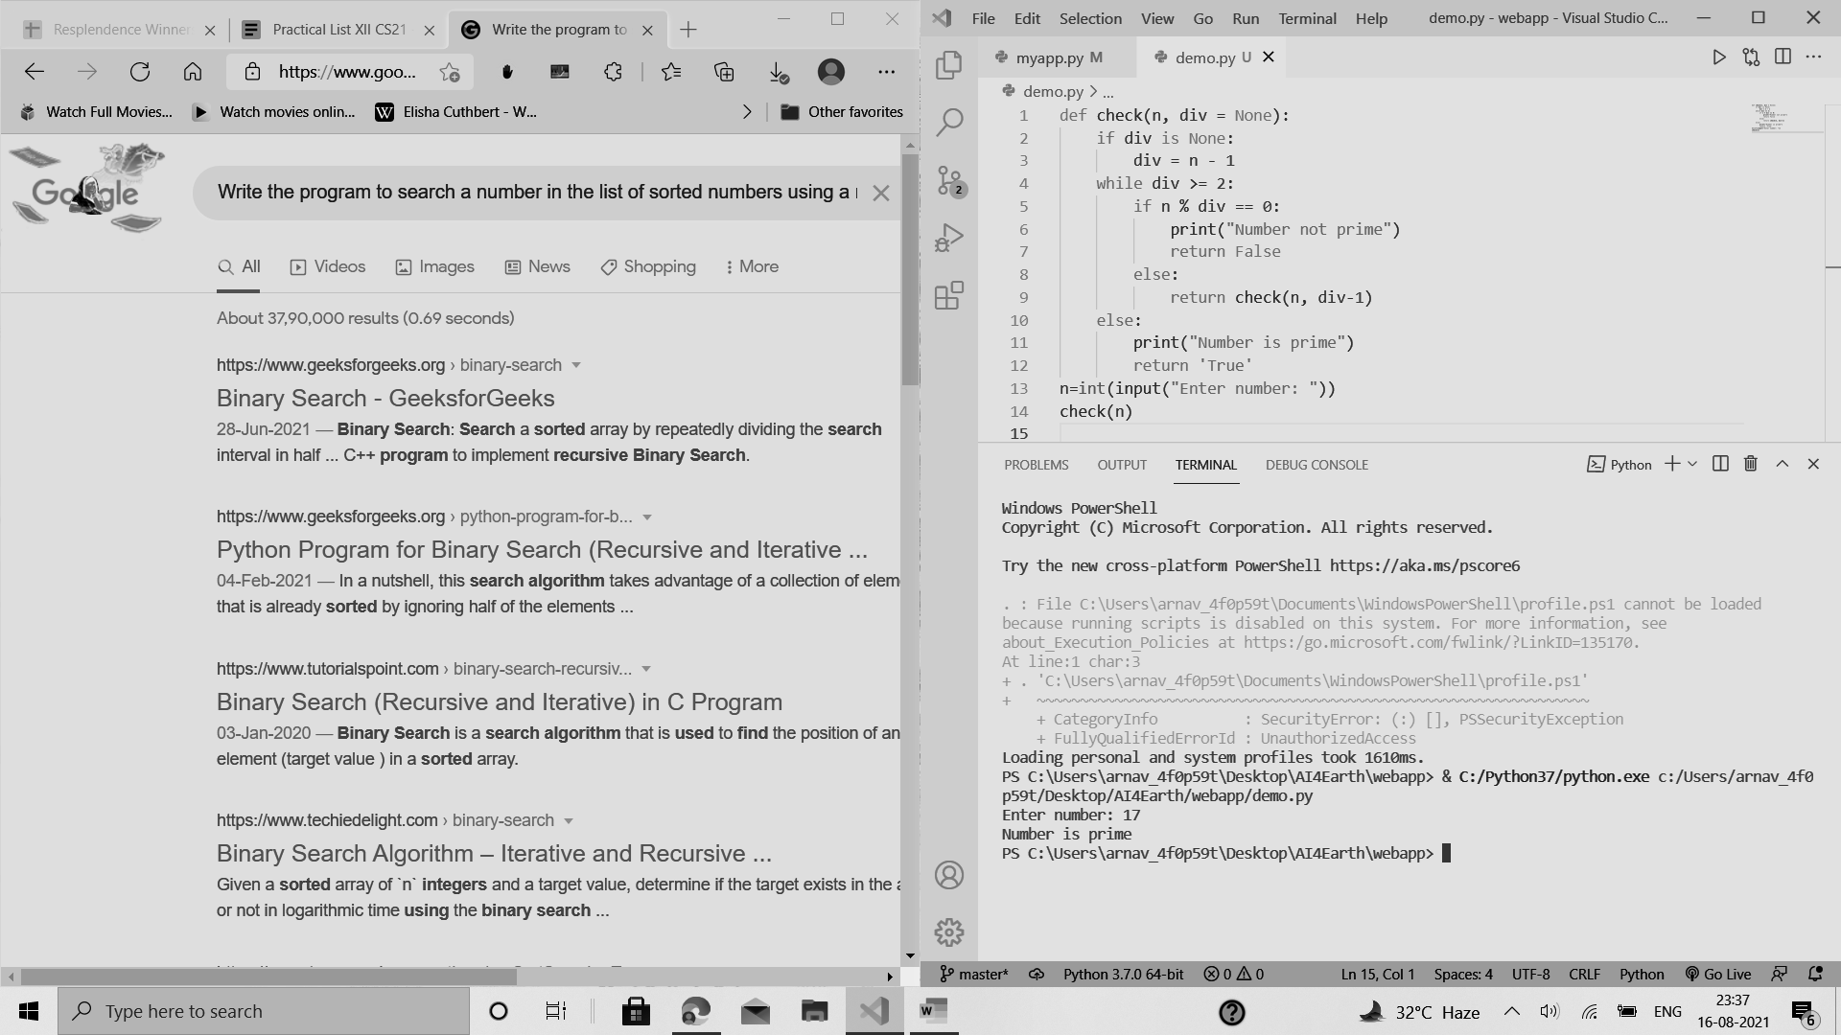 

PRACTICAL 26

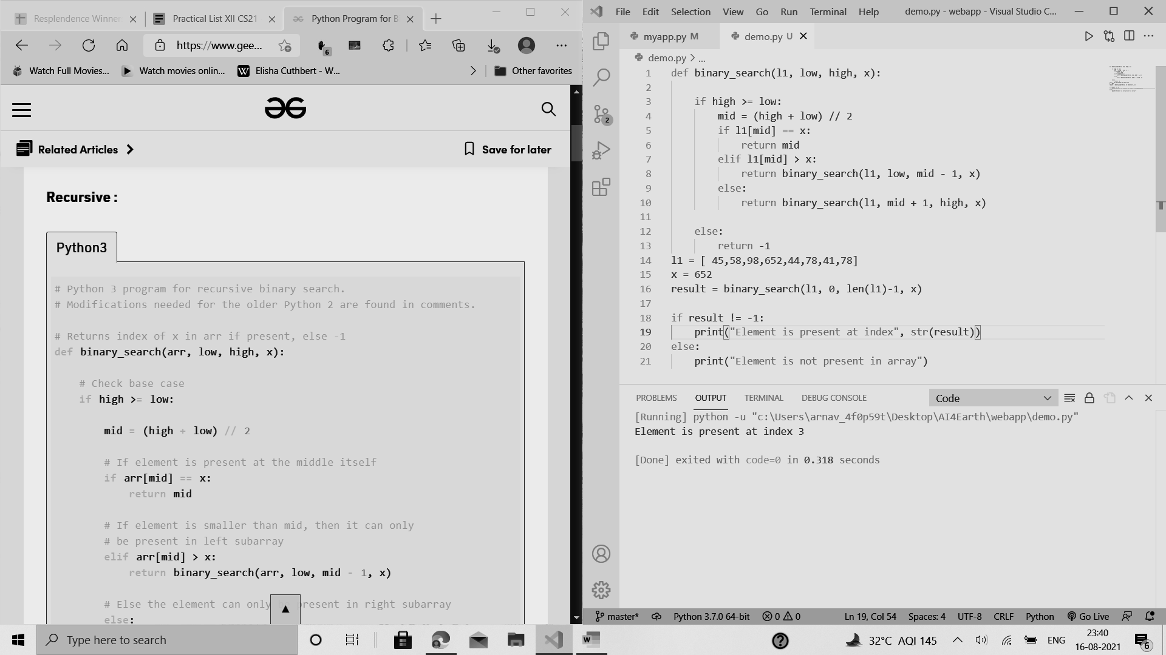

BINARY SEARCH ALGORITHUM

PRACTICAL 27

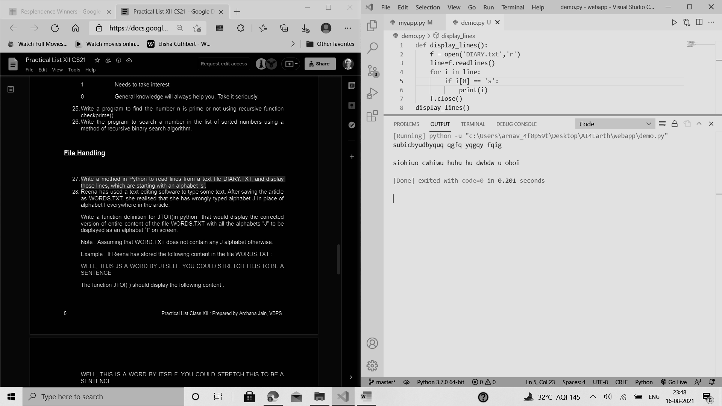

PRACTICAL 28

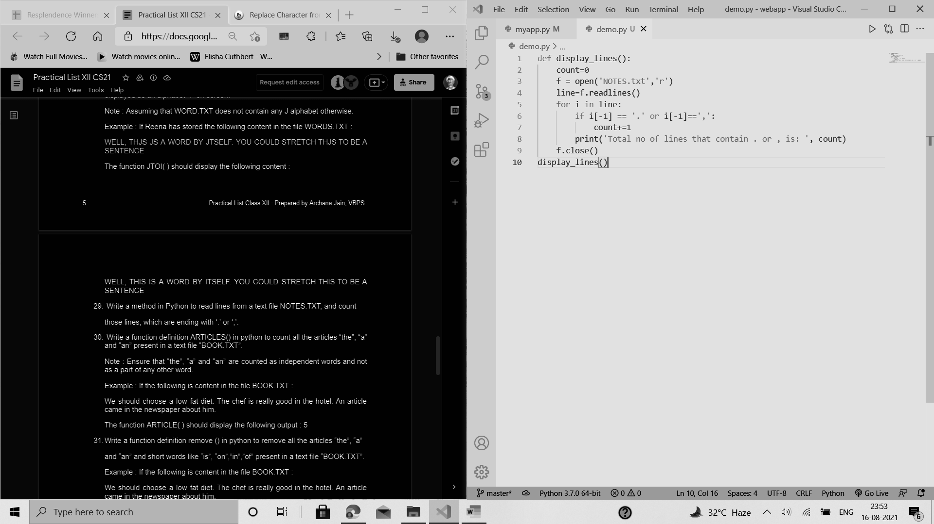

PRACTICAL 29

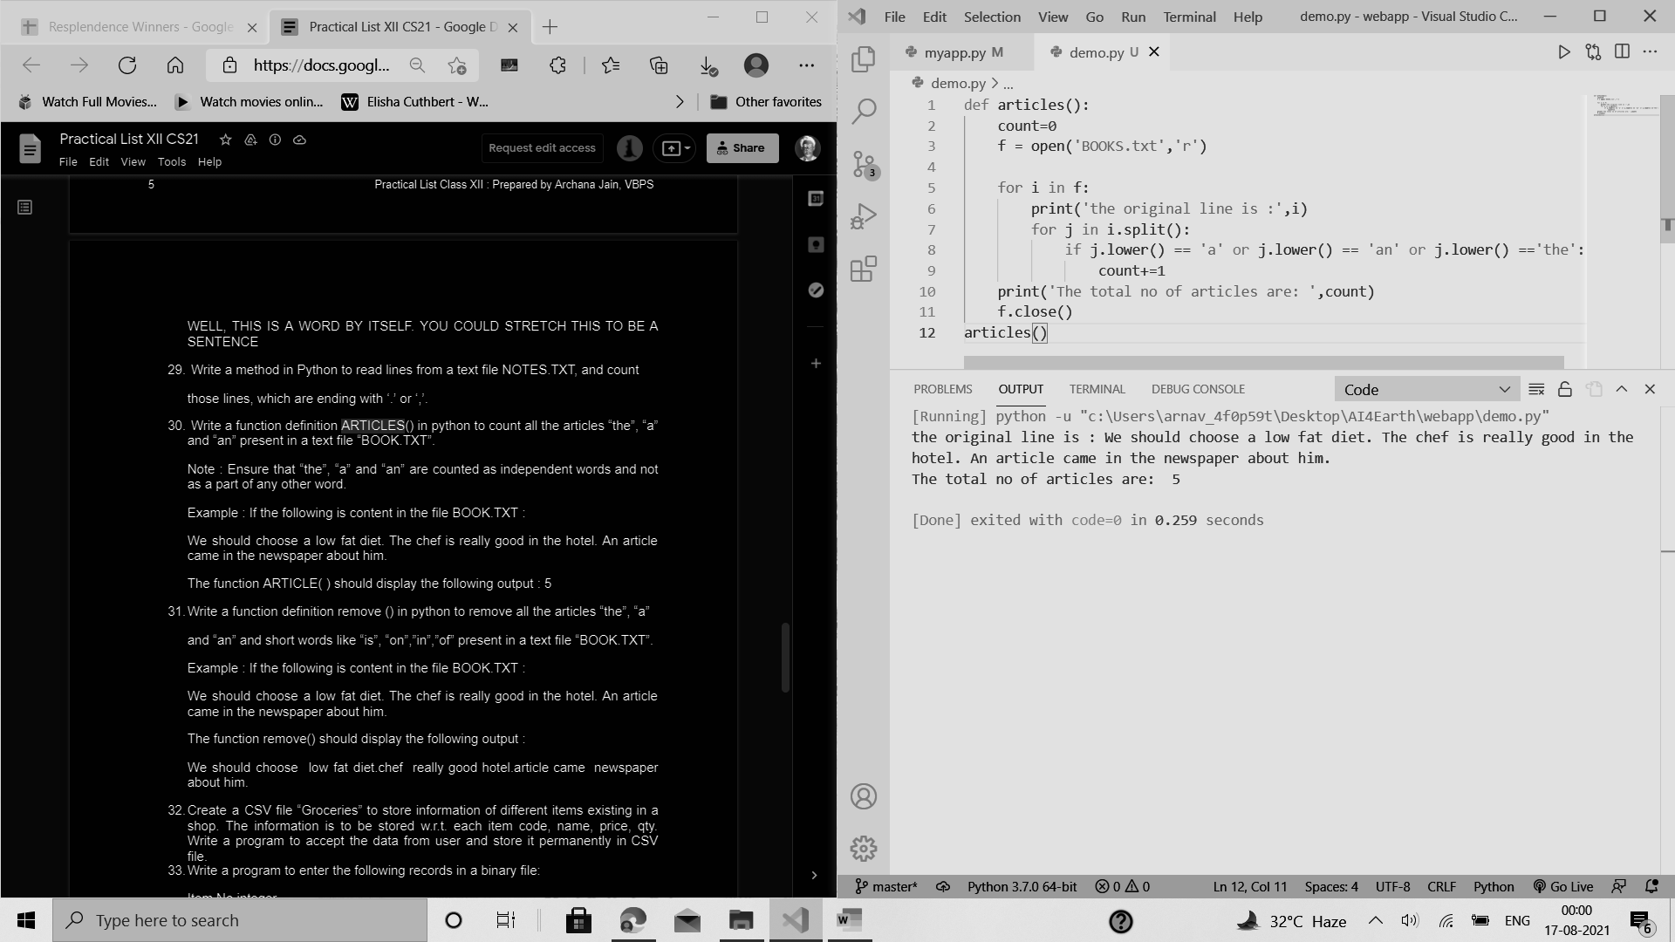

PRACTICAL 30

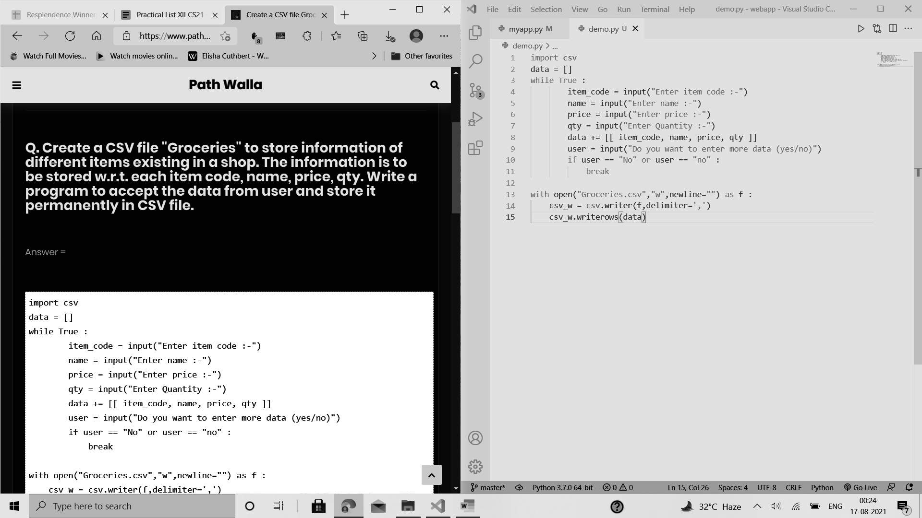

PRACTICAL 31

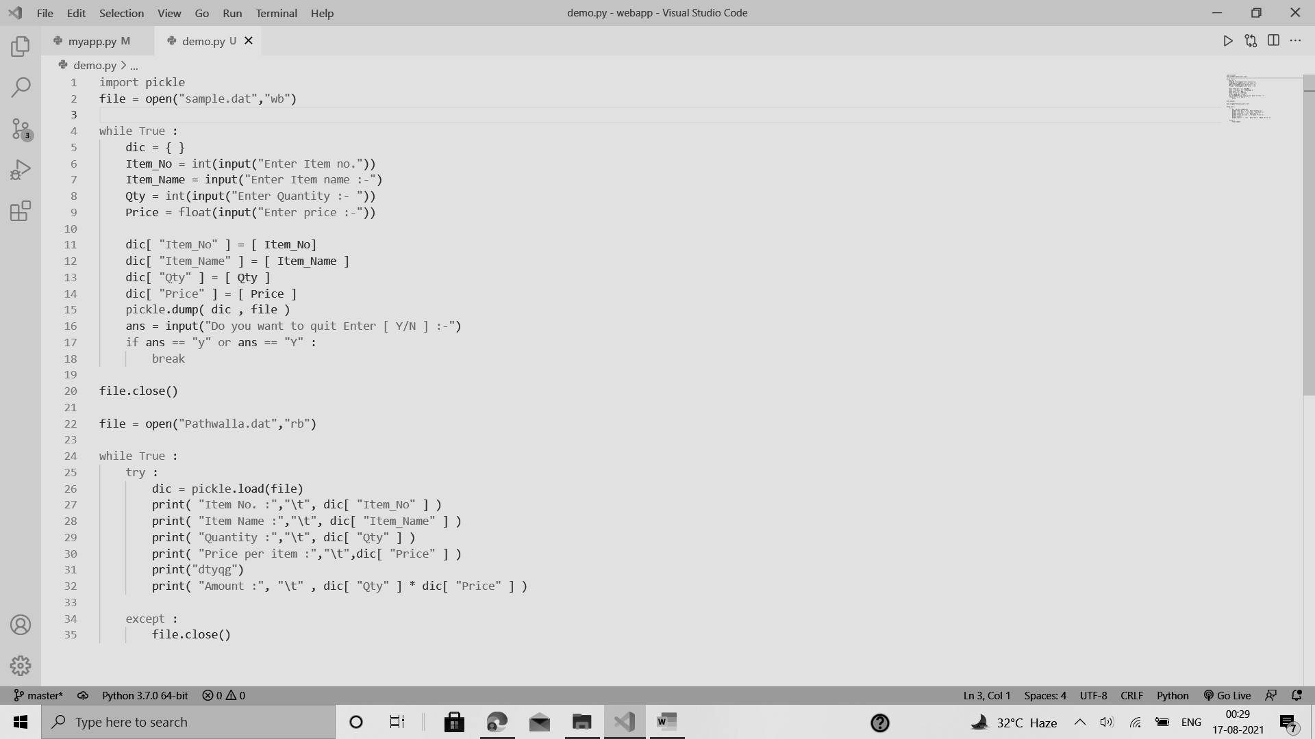

PRACTICAL 32

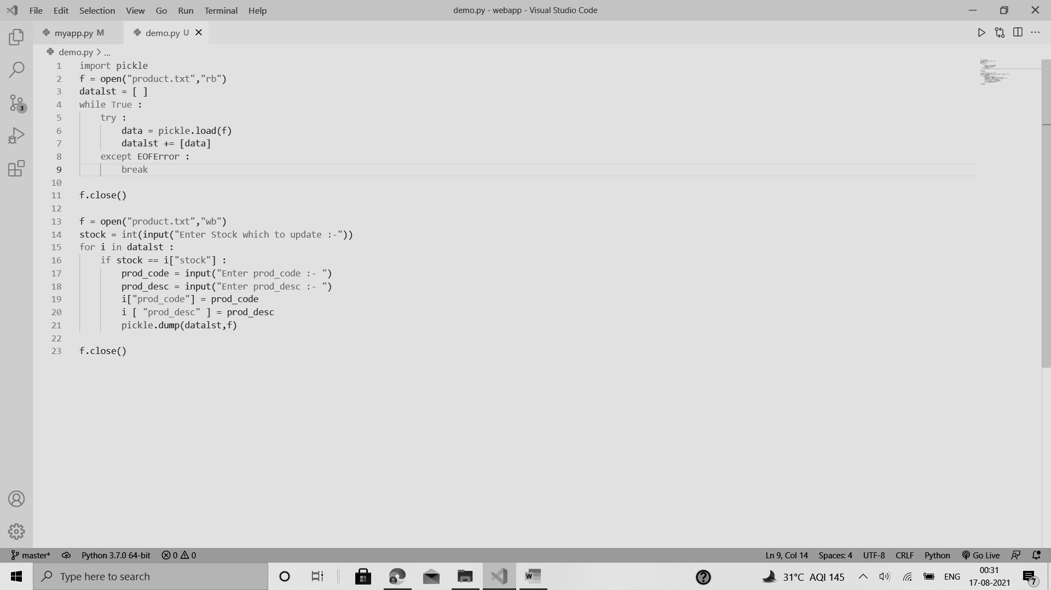

**TABLE OF CONTENTS**

|  |  |
| --- | --- |
| SERIAL No. | CONTENT |
| 1. | ACKNOWLEDGMENT |
| 2. | PROJECT SYNOPSIS |
| 3. | Goals |
| 4. | ABOUT PROJECT: *Front-End* |
| 5. | Back-End |
| 6. | **MAIN CODE** |
| 7. | **Modules Used** |
| 8. | **Database & Tables** |
| 9. | Project Screenshots |
| 10. | HARDWARE SPECIFICATION |